# Secure Development with GitHub Copilot

We can ask in the if code has any SQL injection, insecure data handling (over posting of data issue).

We can manage chat configuration centrally in our repo by creating a file name as copilot-instructuions.md. Other files can be code-style.md and code review or pull request instructions files.

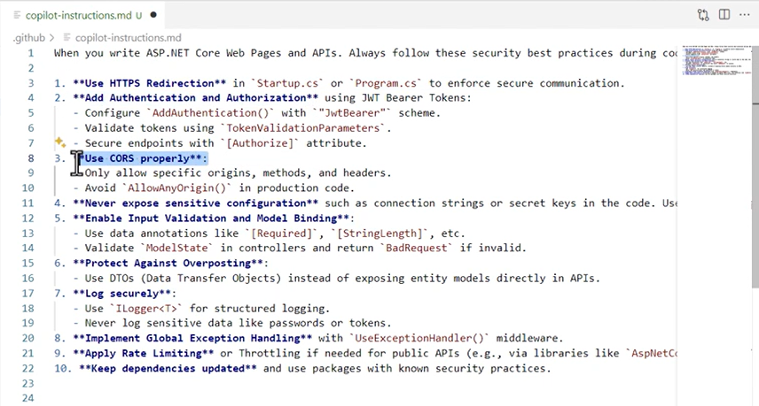

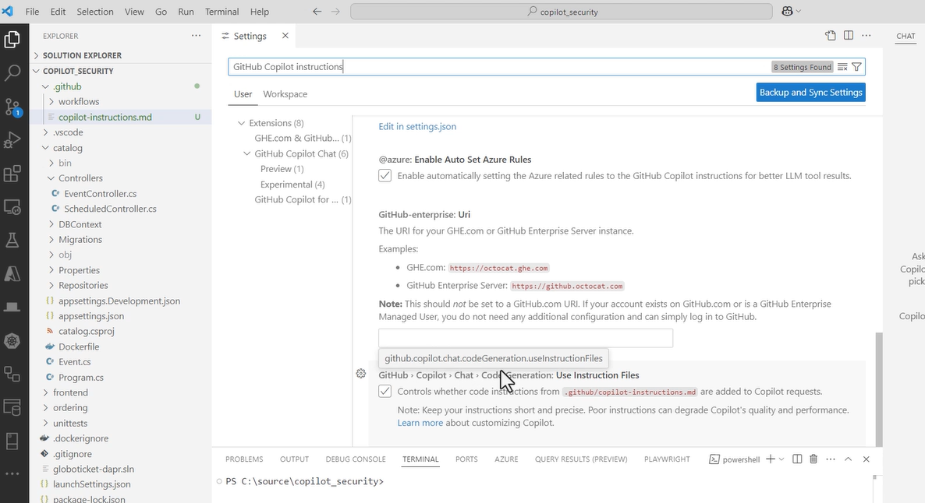

Using advanced security auto fix feature –

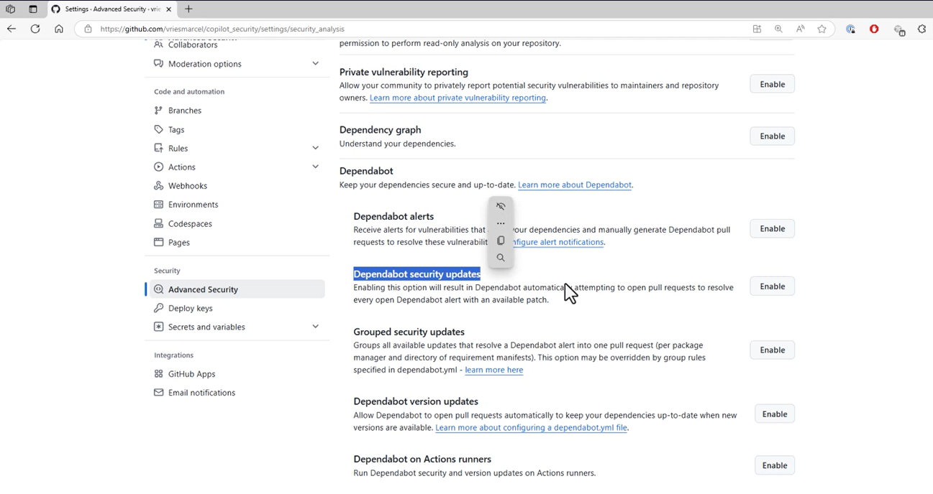

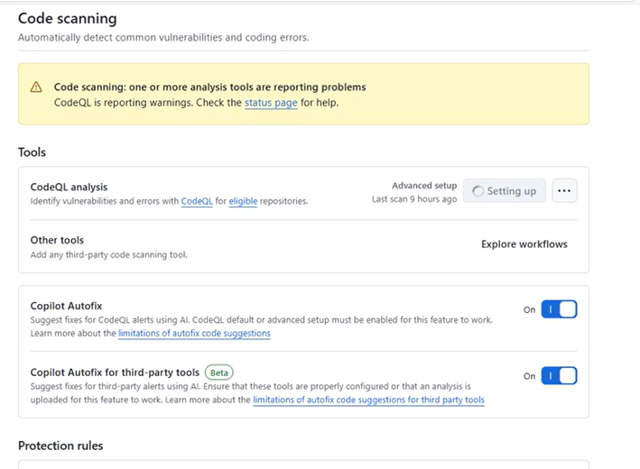

# Cypress: Advanced Test Writing for Modern Applications

Why tests fail intermittently –

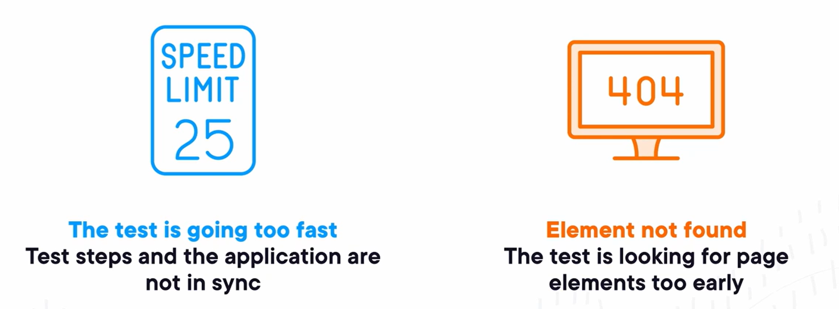

Actions in Cypress are not retried and are only executed once. So those should be end of the chain so the entire chain that selects the subject for our action is retired. Forgetting about this rule will make our tests unreliable.

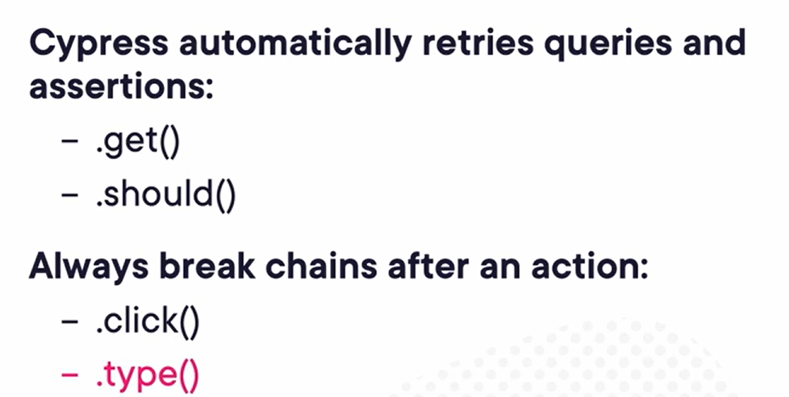

So as a best practice, instead with the first approach as below, second approach this will reduce the likelihood of the test failing –

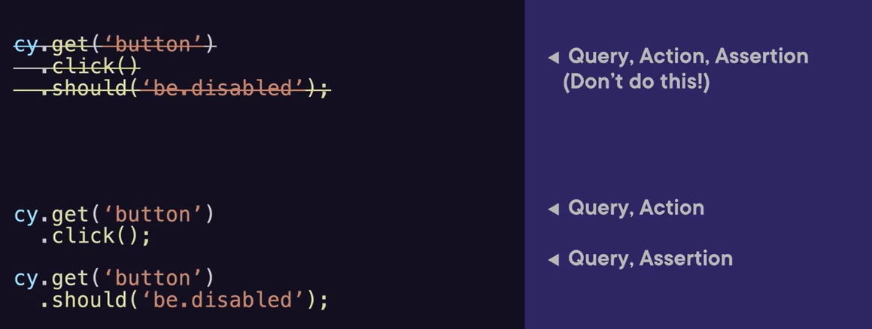

We can also use cy.intercept() to make tests more reliable, we can use this to stub or spy on API calls –

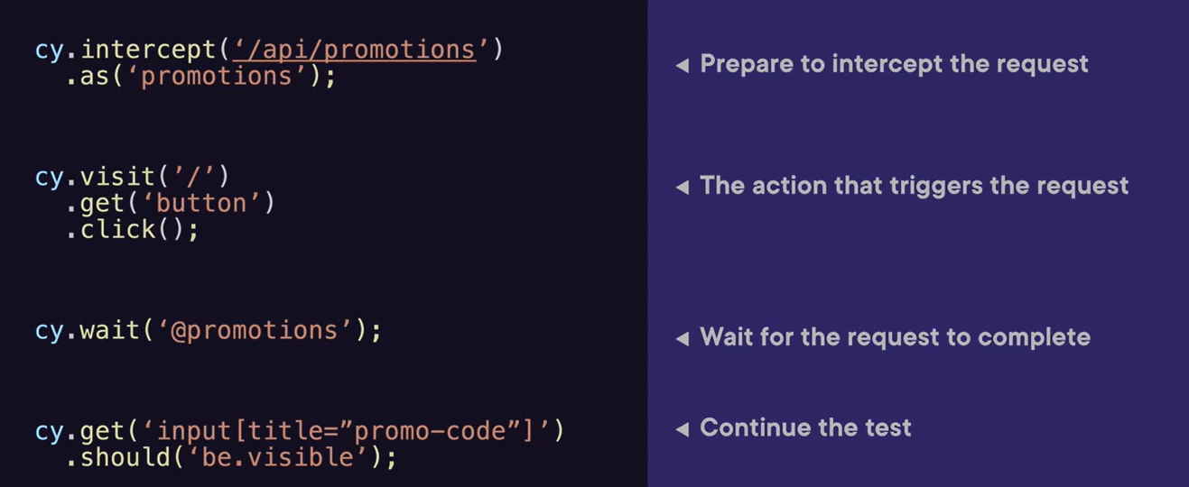

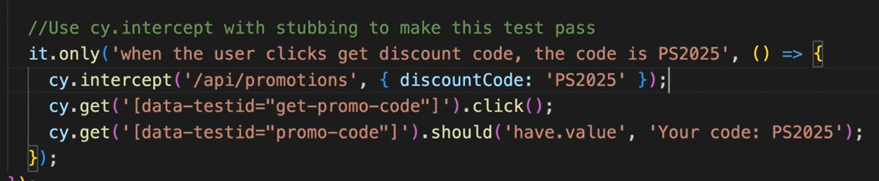

Different types of application state – component state, URL state, server state, global state.

Fixtures are simply files stored in our project that we can load and then pass on to other Cypress commands. Fixtures make test more readable, reusable and better organized.

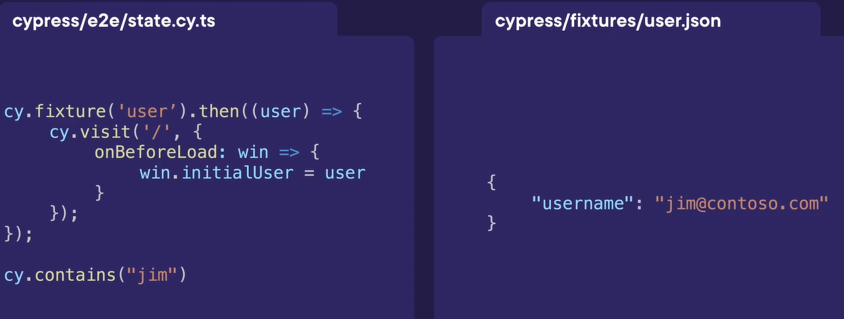

Categories of plugins – preprocessors, development tools, custom commands, component testing, framework extensions, integration, etc.

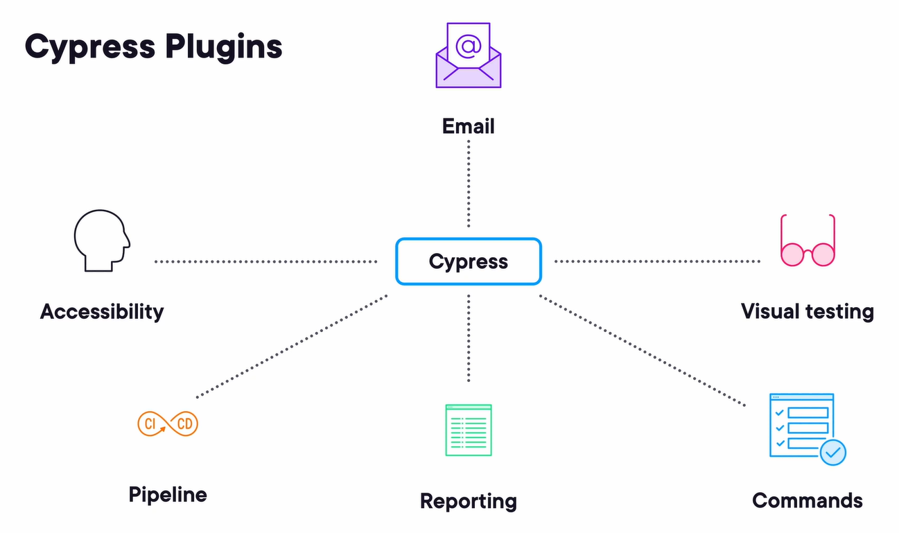

# Cypress: Data Management and Mocking

Data management in Cypress – static test data, data generated during execution, data from HTTP APIs and databases, strategies for sharing data between tests, sensitive data.

Using fixtures and data function –

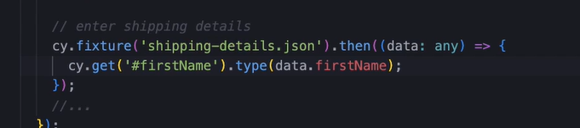

The cy.wrap() command can be used to work with non-cypress promises and objects .

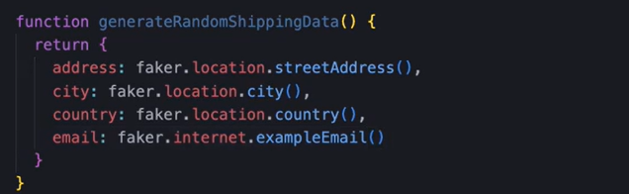

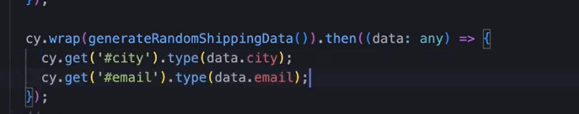

Getting data from API using cy.request().

Getting data from database using –

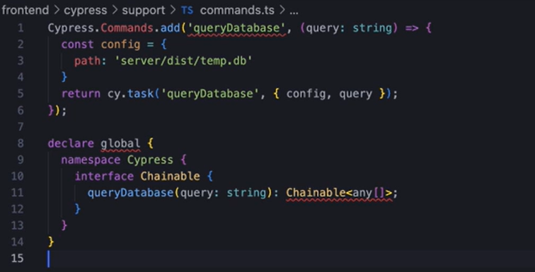

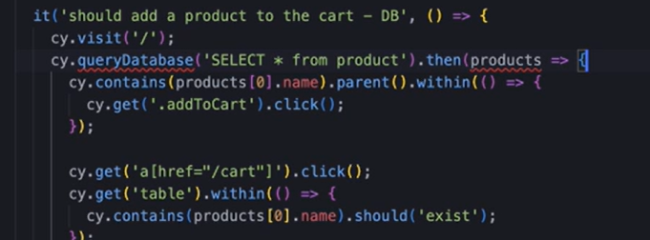

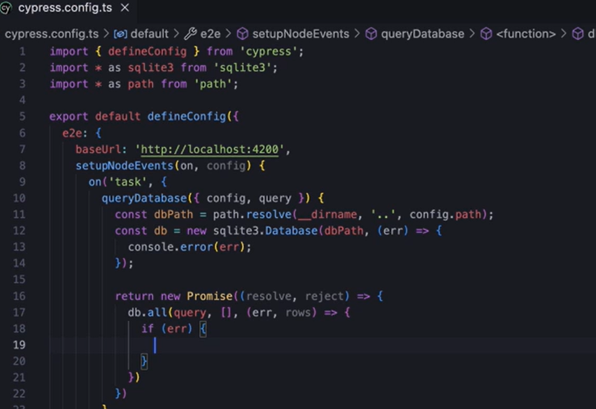

Handling sensitive and environment specific data – the sensitive data should not be hardcoded in test files, checked into a version control system or exposed through logs or errors.

Different ways to specify environment variables –

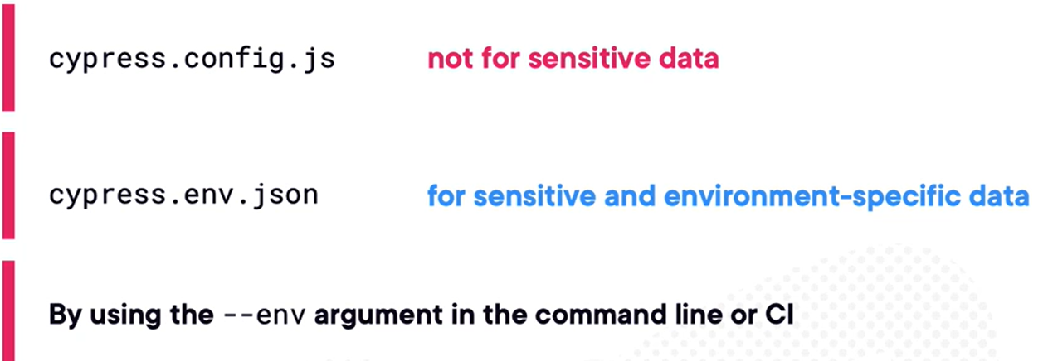

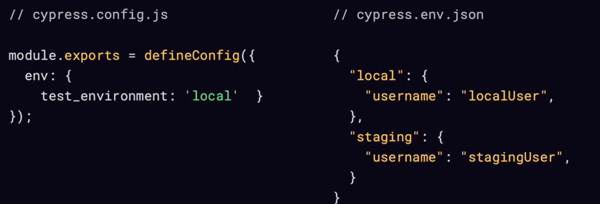

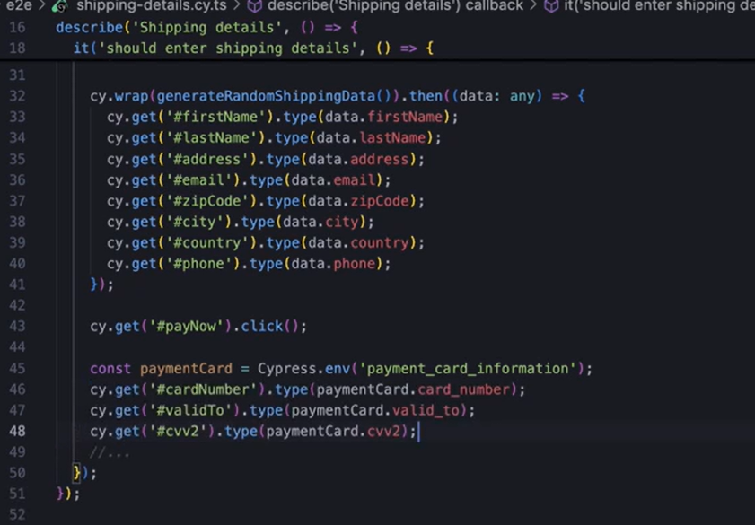

We can introduce dependencies between tests by not making them individual, it will be helpful in below scenario however Cypress recommends against this. We can share data between tests by creating variables outside the tests or we can use cypress and function –

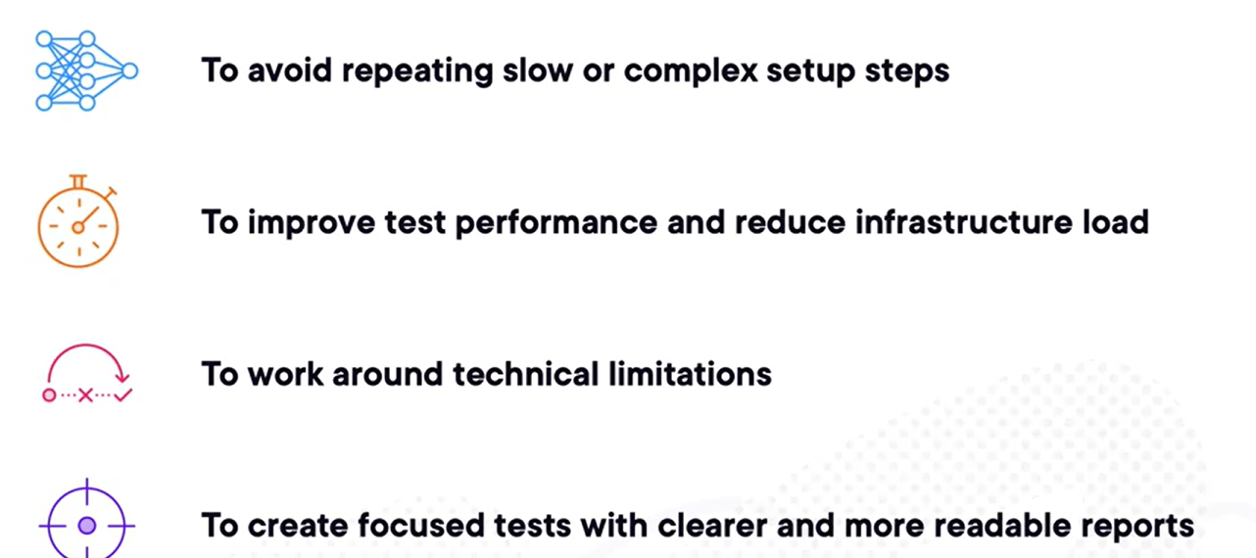

In below example, second test depends on the execution of the first test case -

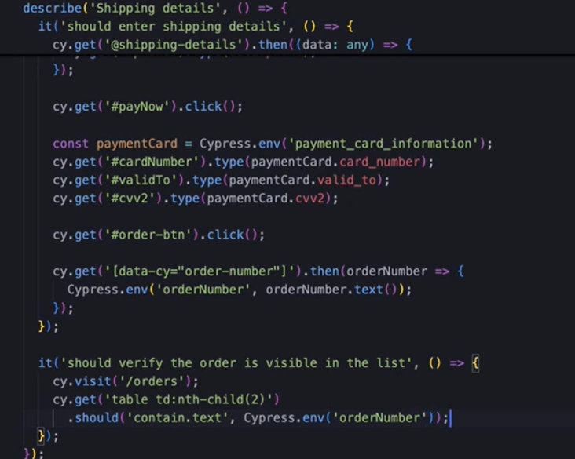

WebSocket connection gets used in chat applications, online games and collaborative tools.

Testing WebSocket –

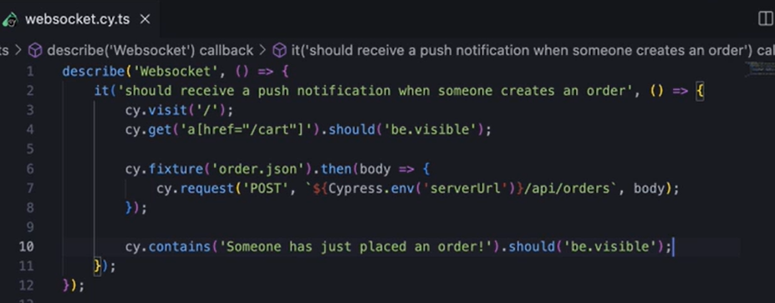

# CI/CD Integration with GitHub Copilot

Making a robust pipeline –

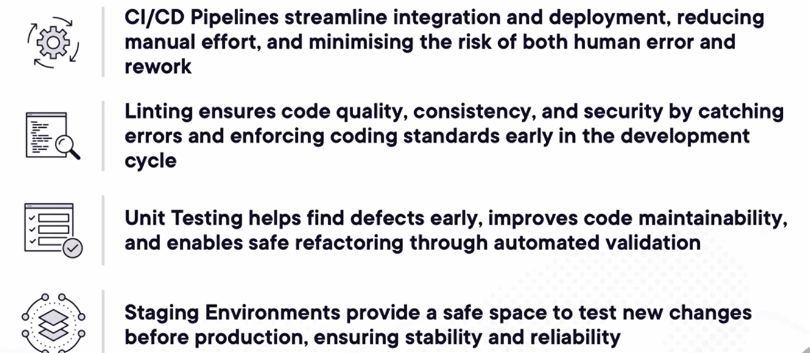

Static Application Security Testing (SAST) in CI/CD Pipeline analyses source code, bytecode or binaries before execution, identifying security flaws early in development.

We can use “npm audit” for checking third party packages, CodeQL for code scanning.

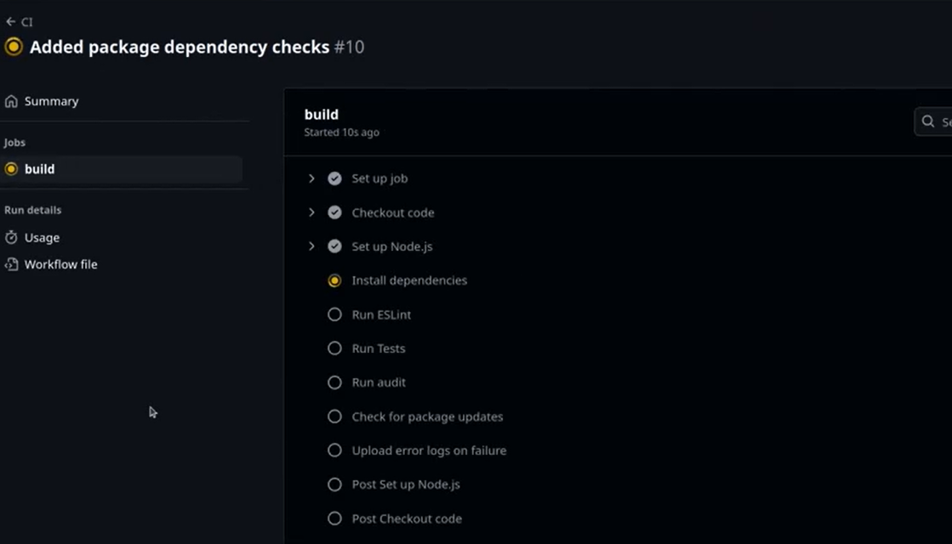

We should run linting, testing, auditing and package update checks into parallel stages by splitting them into different stages.

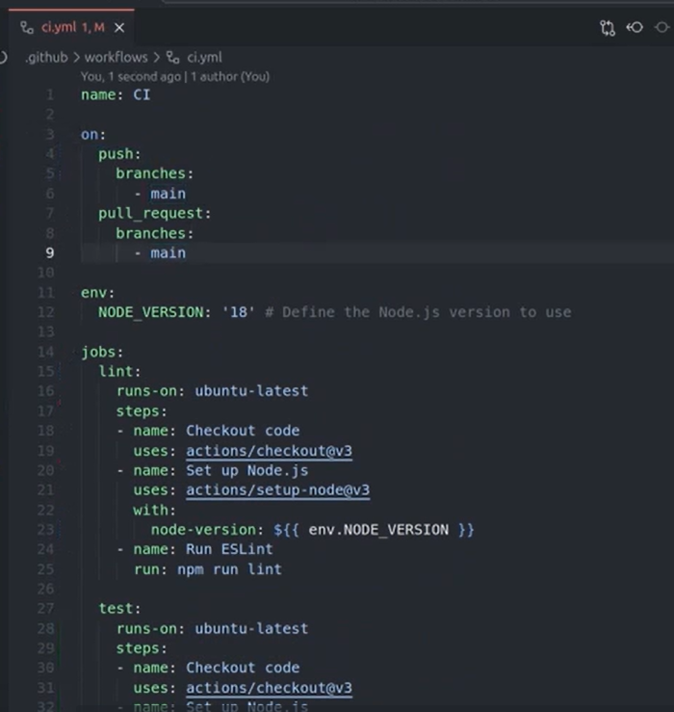

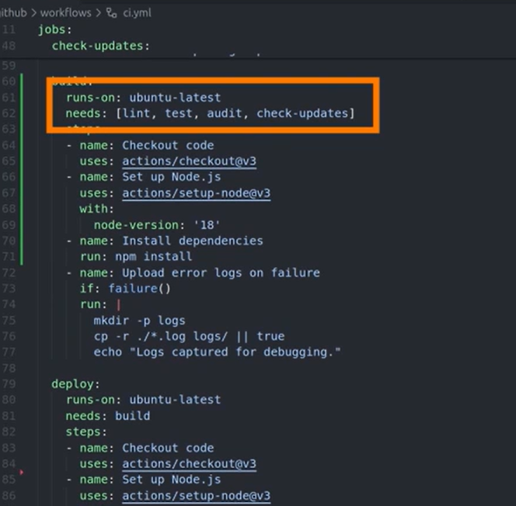

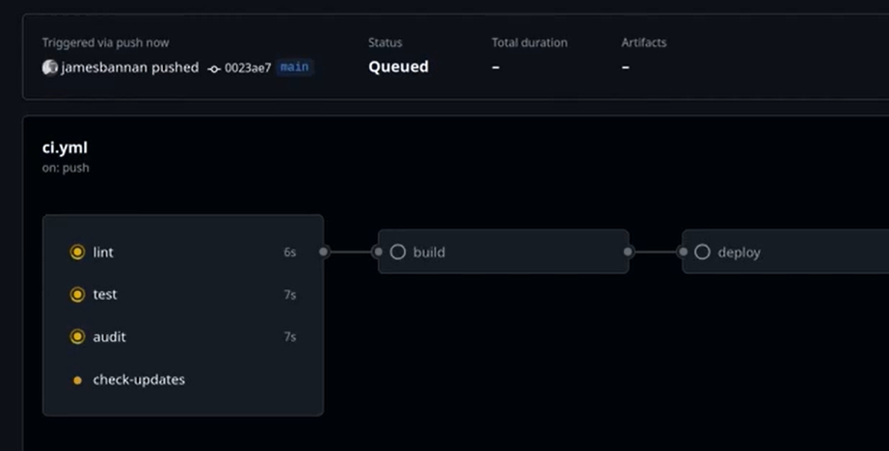

Enhancing pipeline efficiency and clarity – better naming, parallelization, caching strategies, error handling and log generation, security scanning.

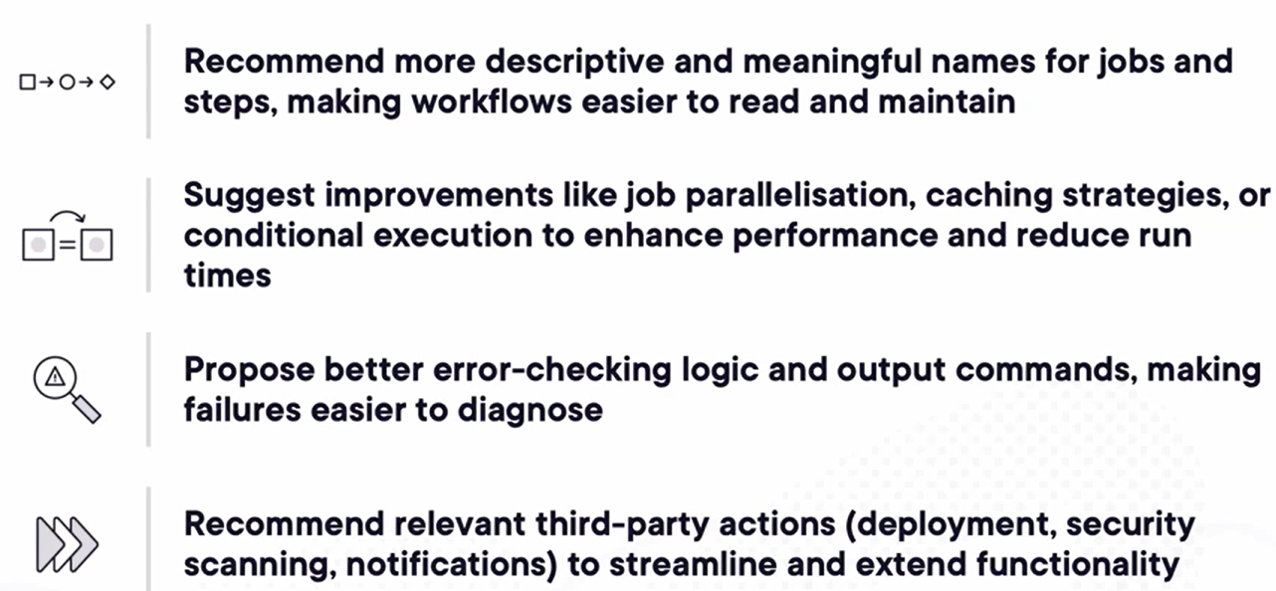

We can avoid retriggering the build pipeline when some specific file has been modified like readme markdown file.

We can also generate documentation content and mermaid diagram from git copilot prompt –

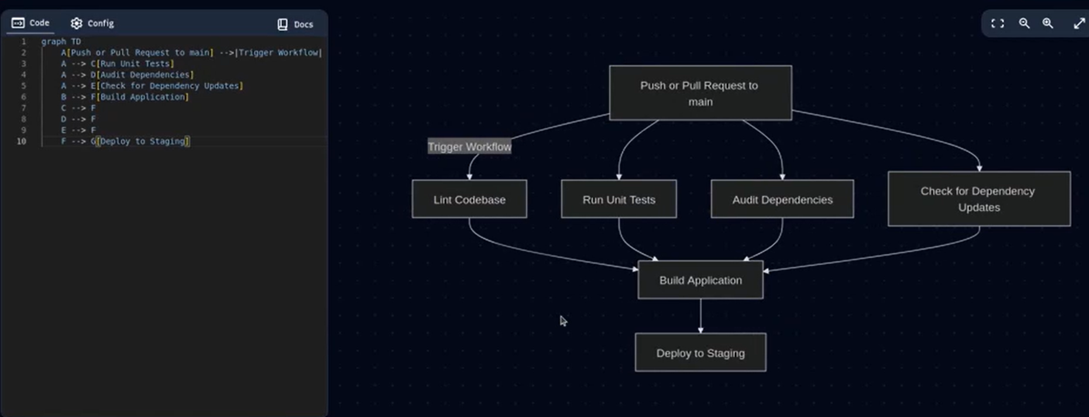

Using ESLint to check hardcoded passwords –

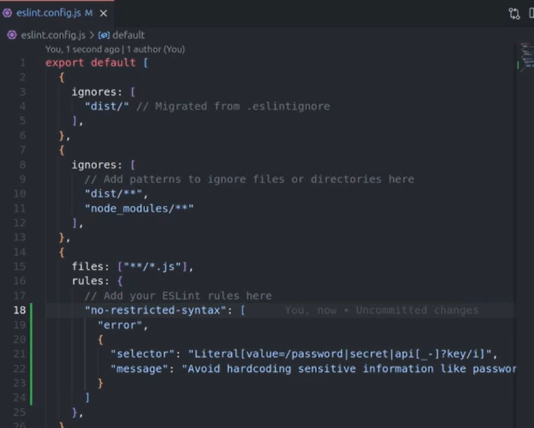

Also, we should use eslint-plugin-security –

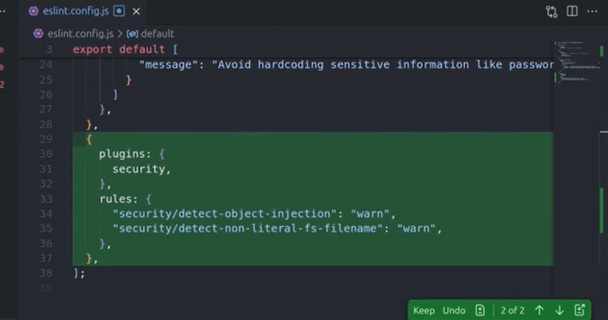

Also, in the CD/CI we should use Trufflehog to scan and detect any exposed secrets.

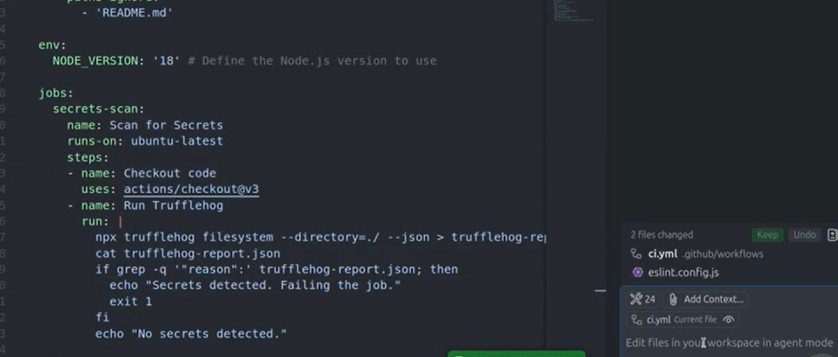

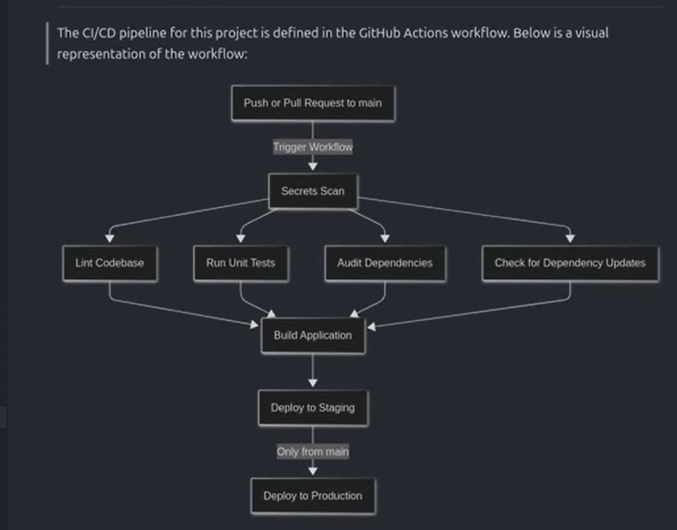

Using Azure vault to store passwords securely –

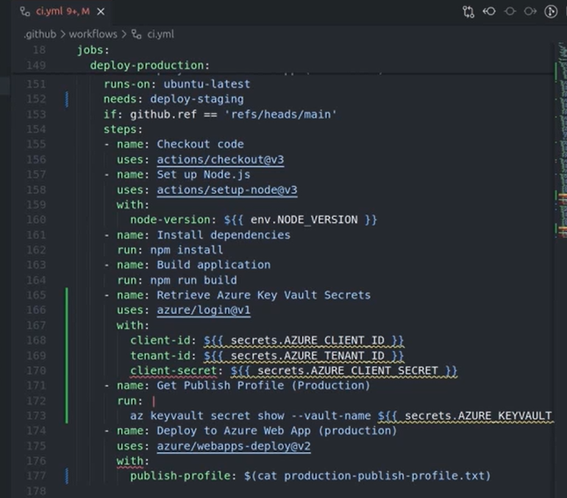

# PostgreSQL Functions Playbook

Installing PostgreSQL in a Docker Container –

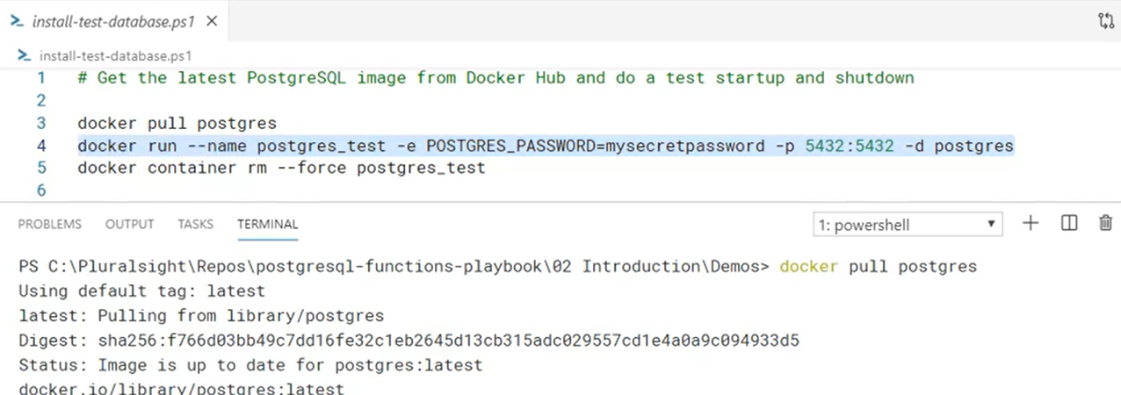

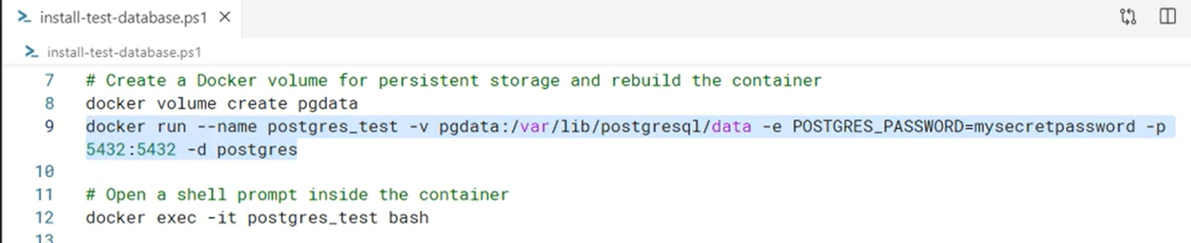

Data types – Character, Binary, Numeric, Date, Time, Interval, Boolean, Array, UUID, XML, JSON, Range, Domain, Geometric, Network, Enum, Bit String.

Byte arrays are good for storing data that cannot be thought of as textual like encrypted passwords, hashes, images and sound clips.

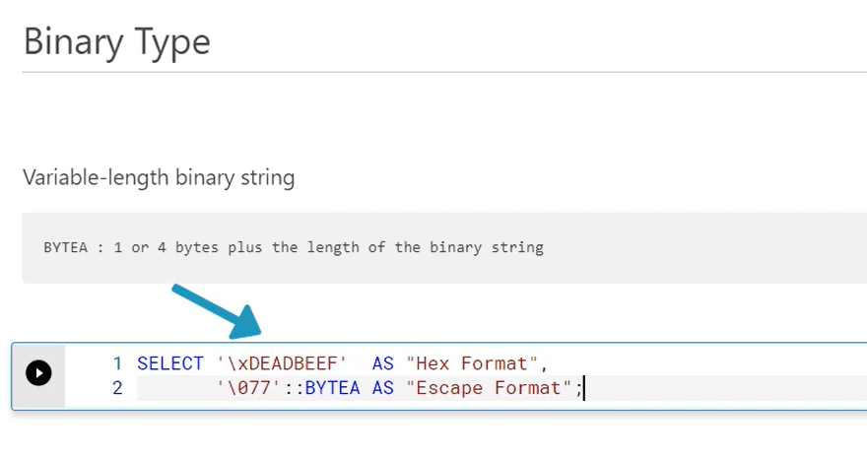

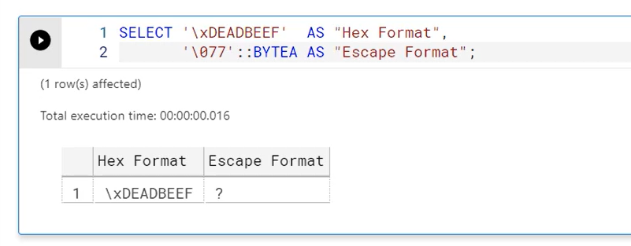

Floating point types are called approximate since they are used to represent real numbers in the mathematical sense, but are stored and processed on actual CPUs which are finite. The REAL or FLOAT4 type specifies single precision as defined by the IEEE 754 standard and the type DOUBLE PRECISION or FLOAT8 corresponds to the standard of the same name. Now because floating point numbers are approximate, some operations like equality comparisons may not always work as expected.

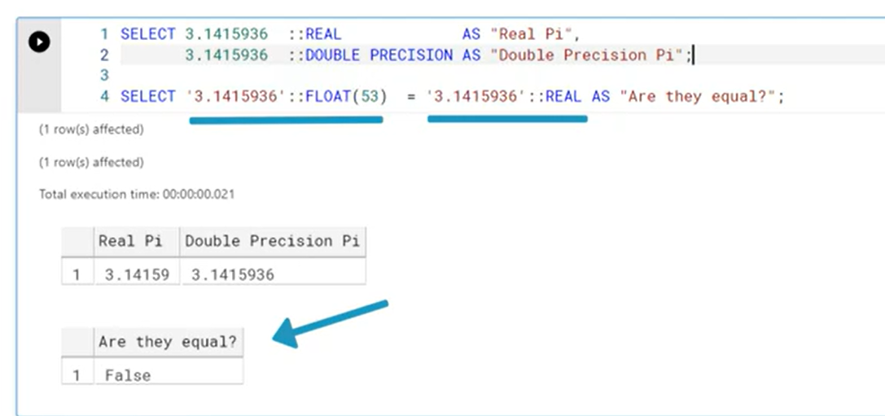

There is one monetary type called money that stores a currency amount with a fixed fractional percentage.

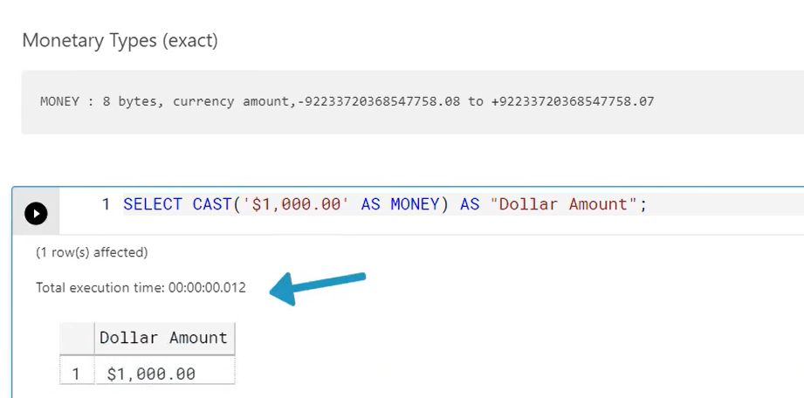

The null represents as a Unknown value –

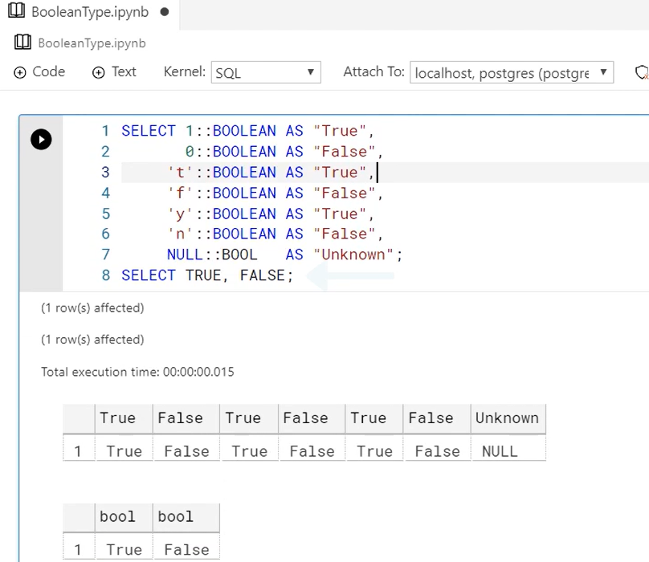

PostgreSQL also supports various math operators and function, mat operators, scalar function, trigonometric values, aggregating functions, statistical functions (standard deviation, variance, correlation), converting and formatting numeric data functions (To_NUMBER, TO_CHAR).

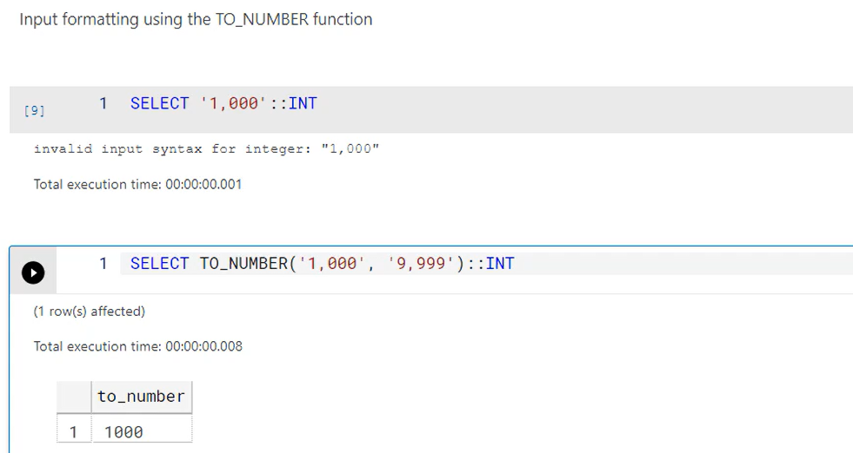

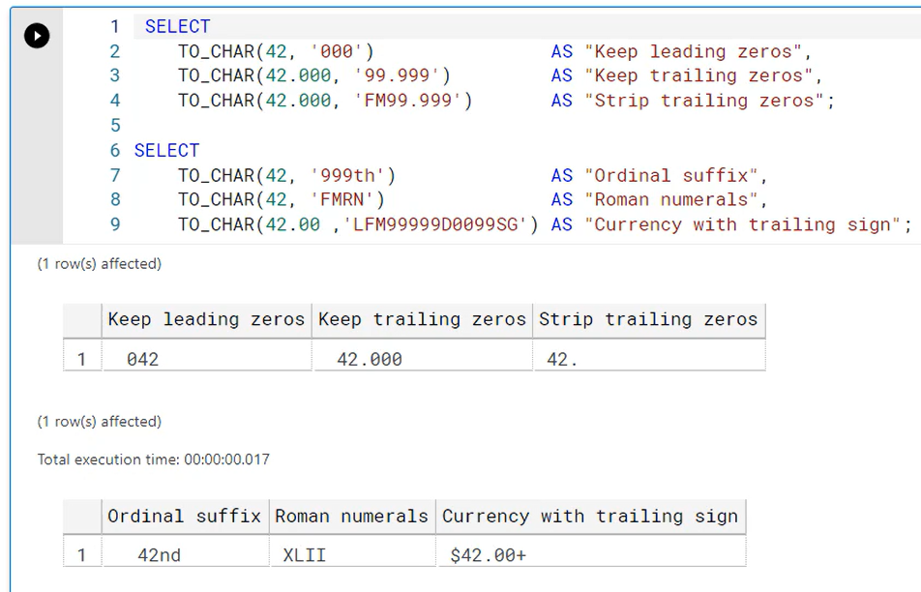

Handling character data with string functions and operators – pattern matching, text searching, converting and formatting.

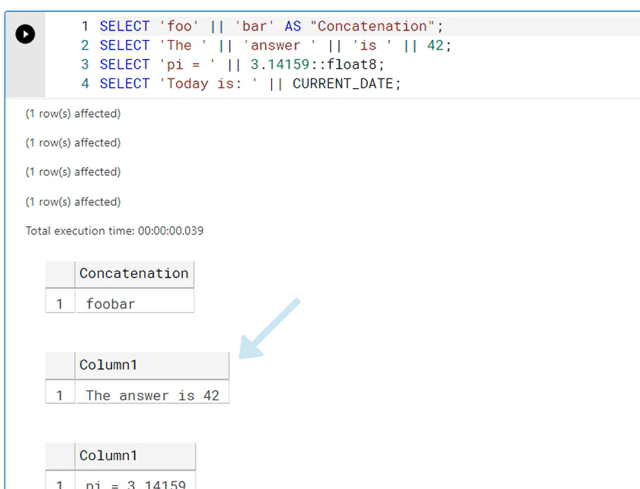

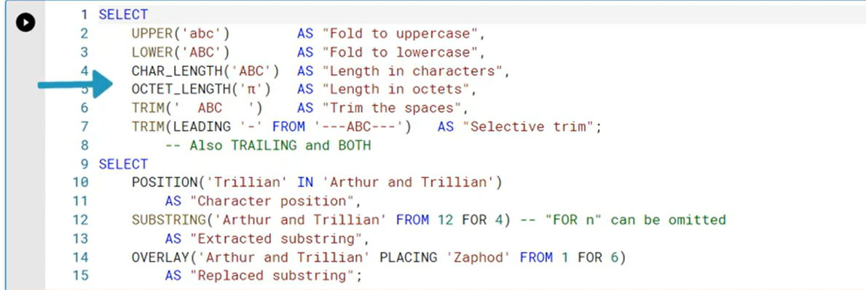

PostgreSQL String functions –

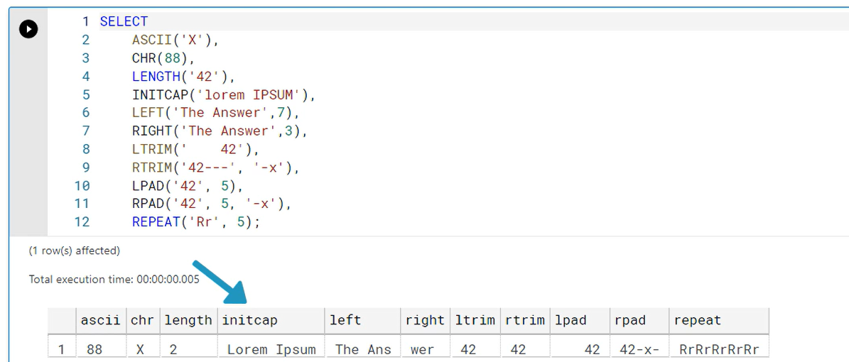

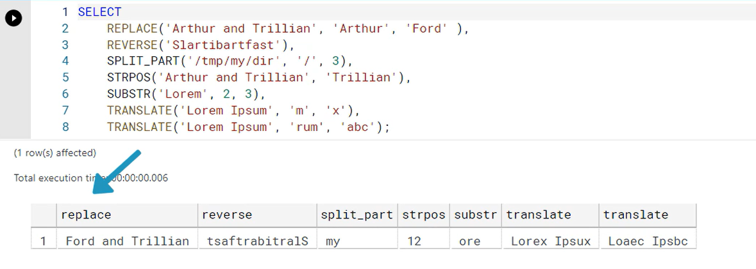

Aggregating textual data – vertical concatenation and horizontal concatenation –

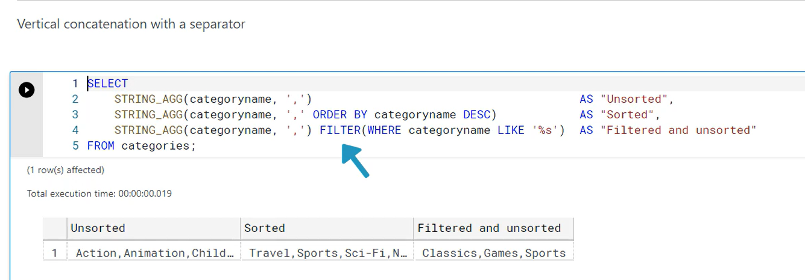

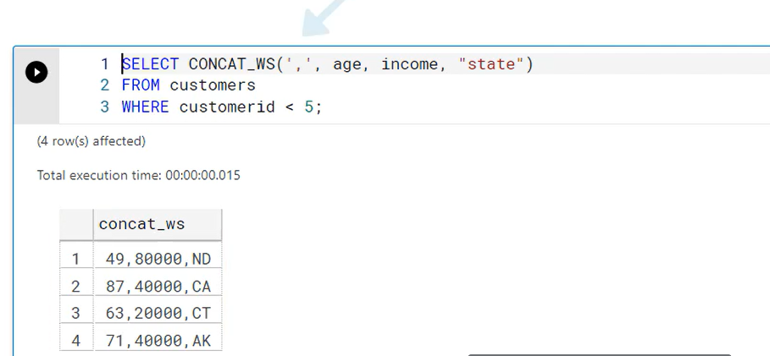

Pattern matching –

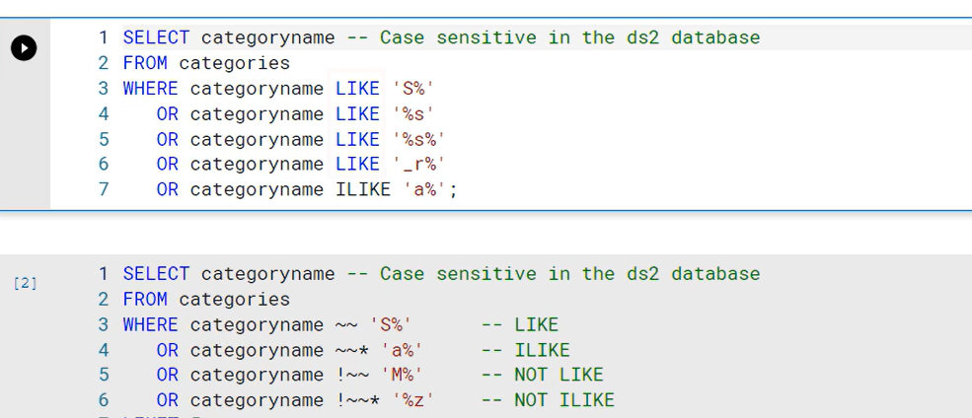

Using regular expressions – more powerful than Like or Similar keywords –

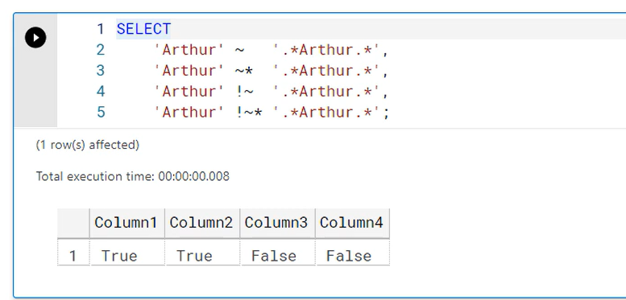

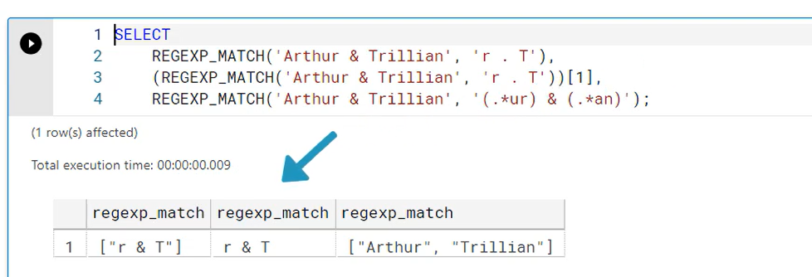

Searching natural language documents –

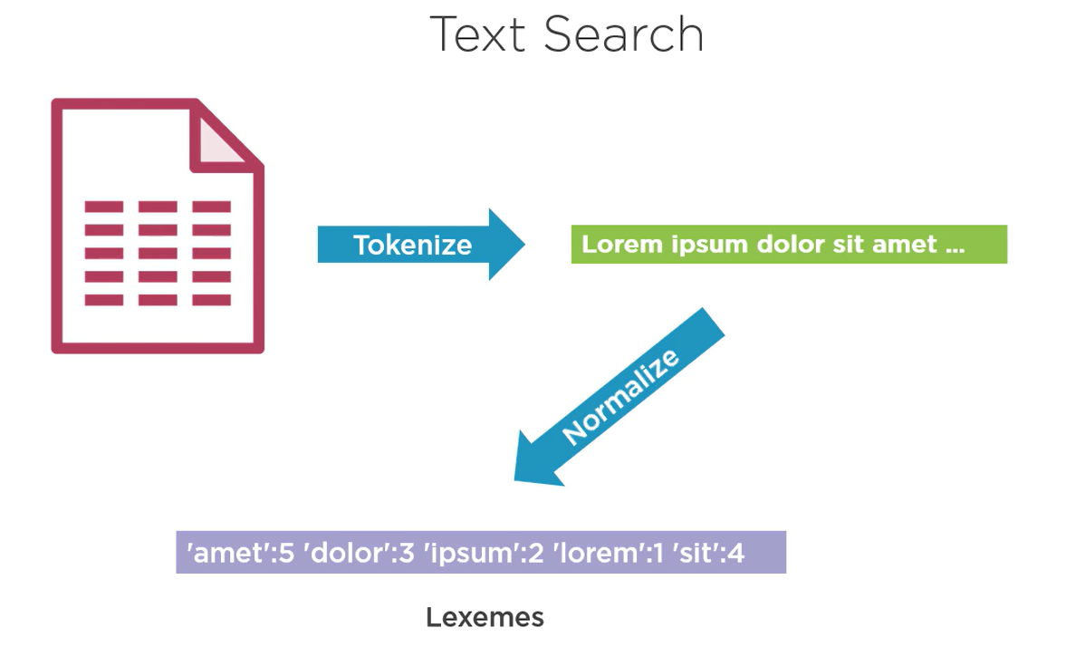

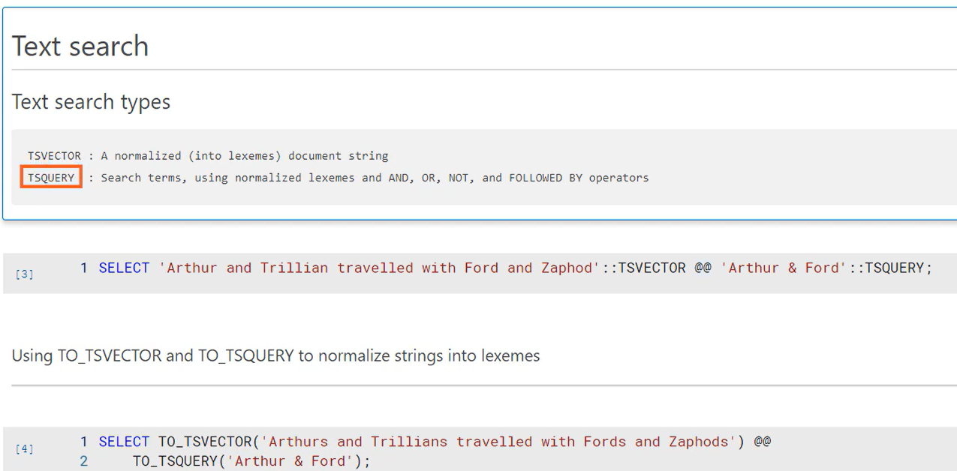

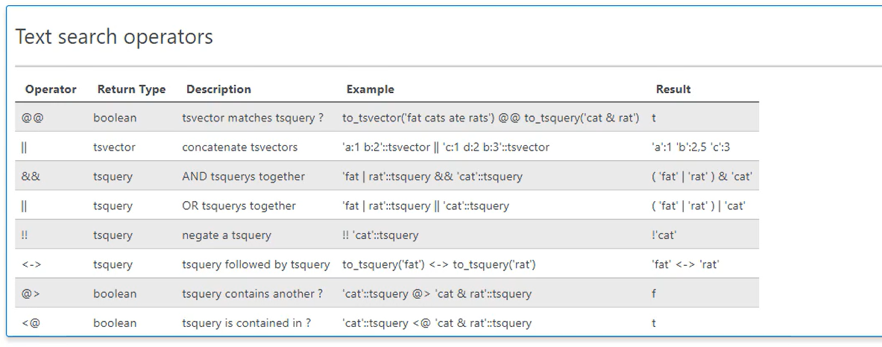

Converting and formatting character data –

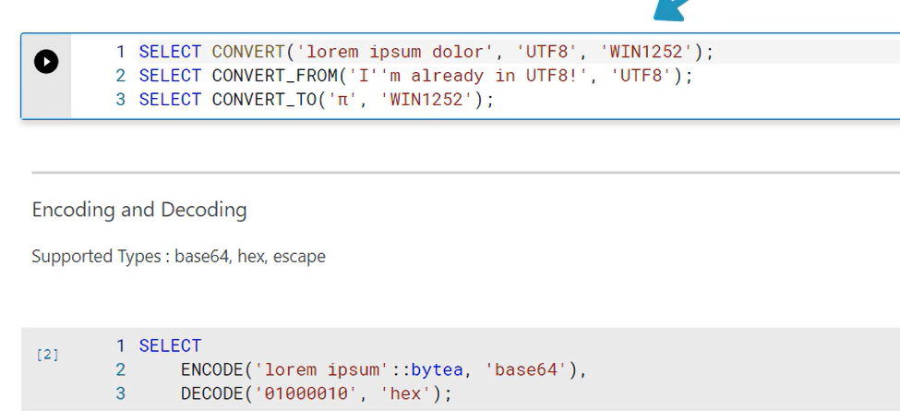

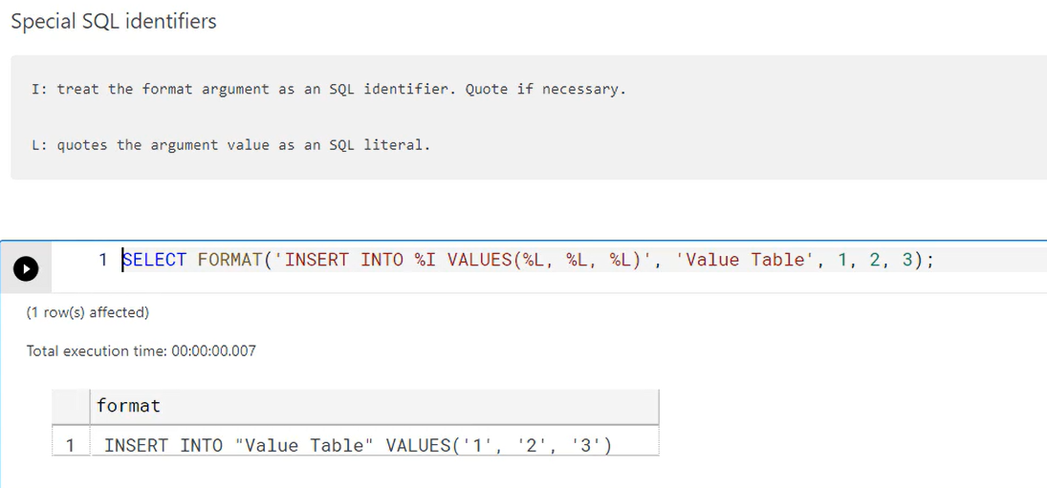

Building and parsing dates and times –

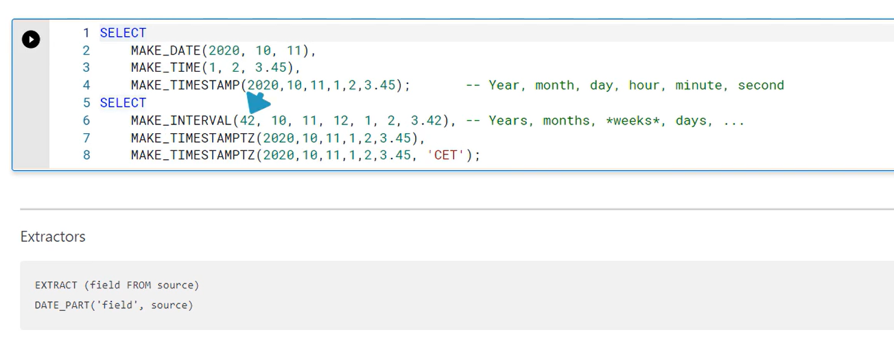

We can simply add the days like below –

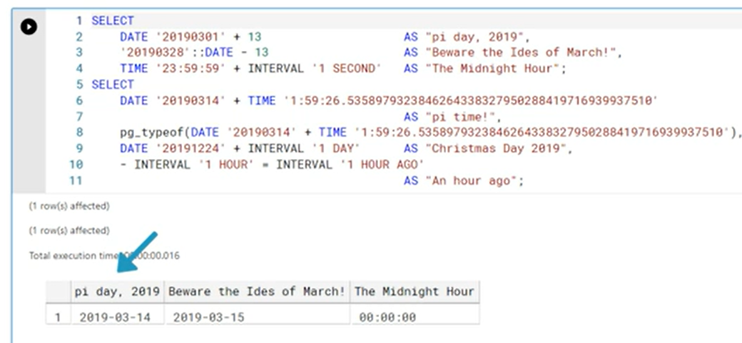

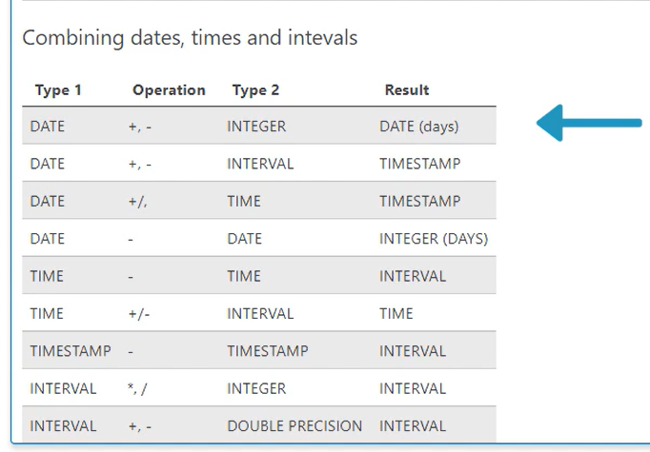

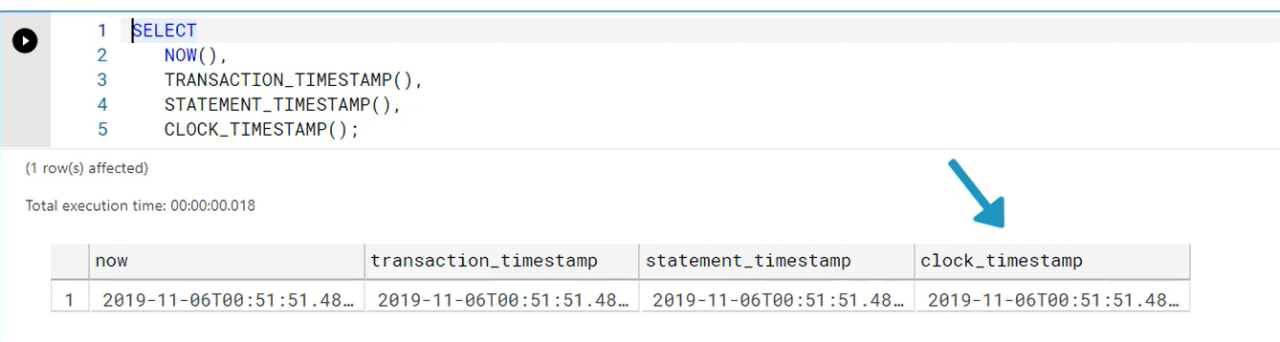

Performing date time with arithmetic can be complex, as for accuracy, we need to consider time zones and also daylight savings time. The EPOCH function helps in these calculations instead of AGE function which might be inaccurate –

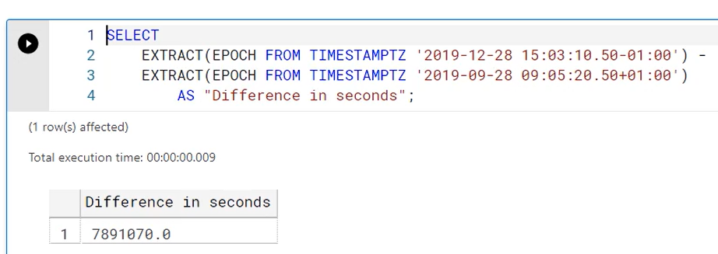

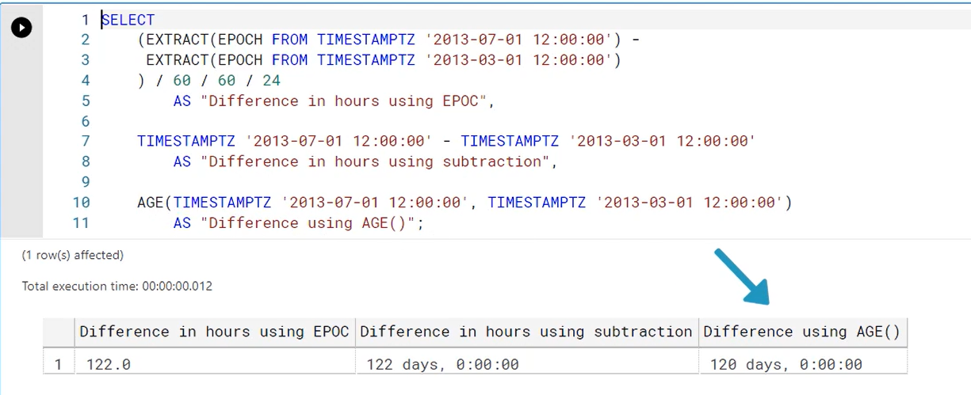

To convert and formatting dates and tie we can u se TO_DATE and TO_TIMESTAMP functions with formatting templates –

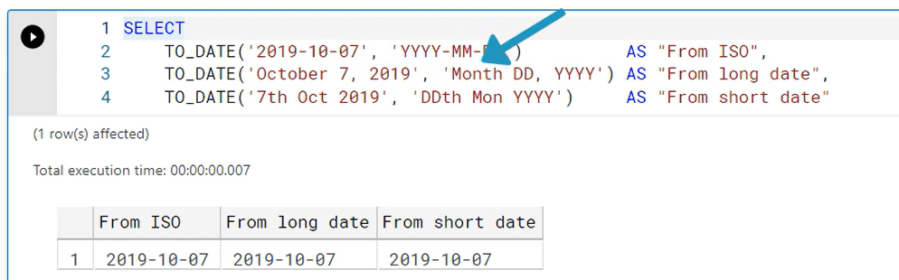

Windowing function

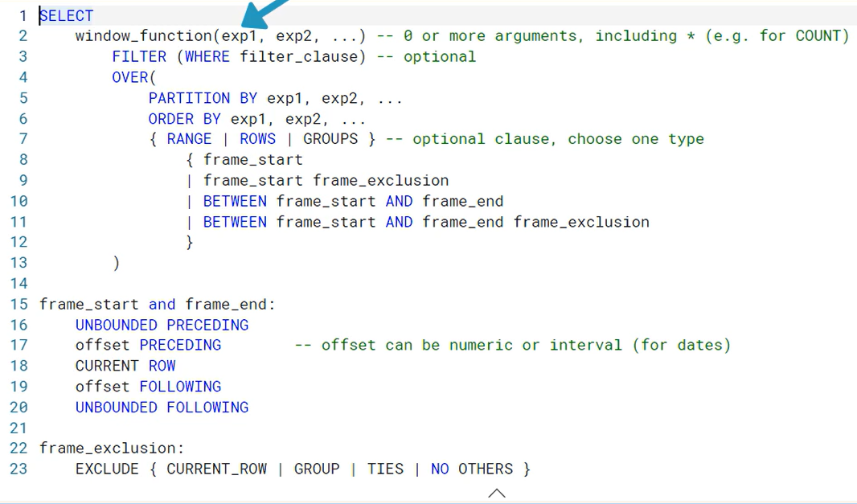

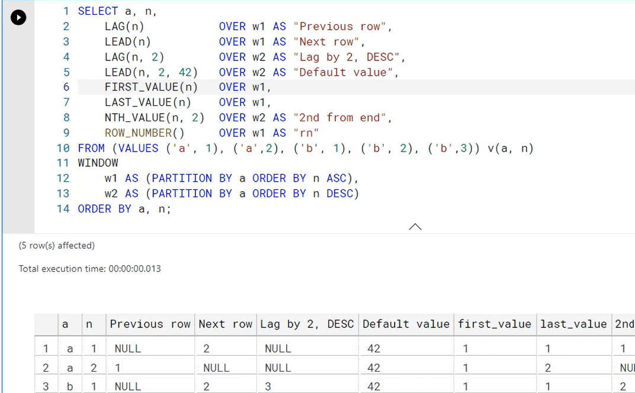

Controlling results with Subquery and Conditional functions – EXISTS, IN, ANY (SOME), ALL functions.

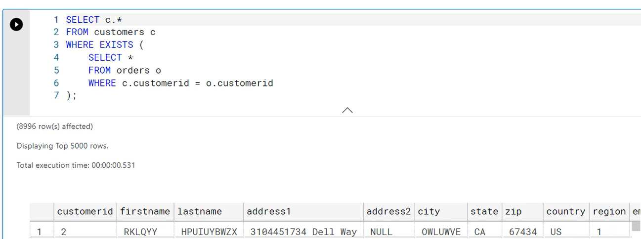

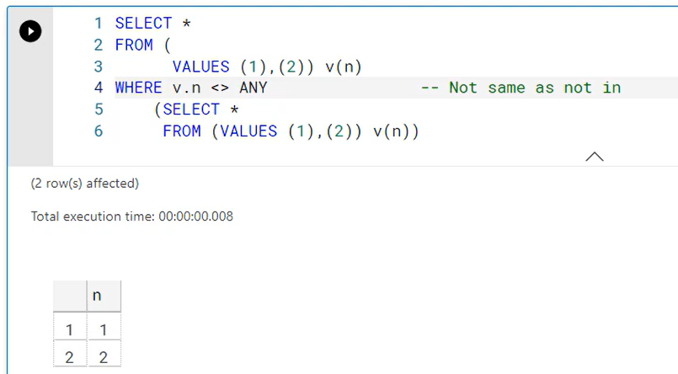

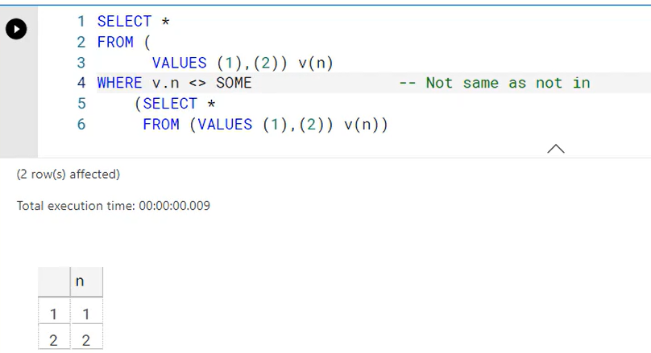

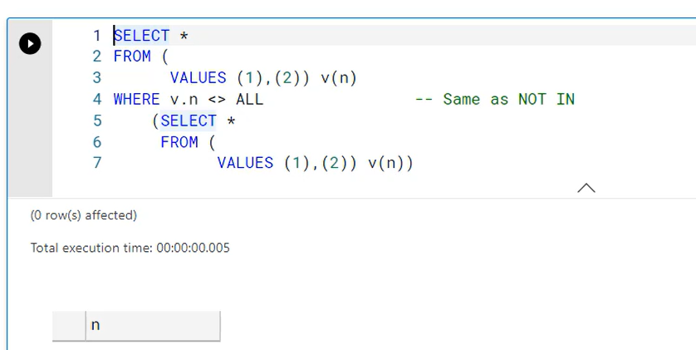

Array and Range functions –

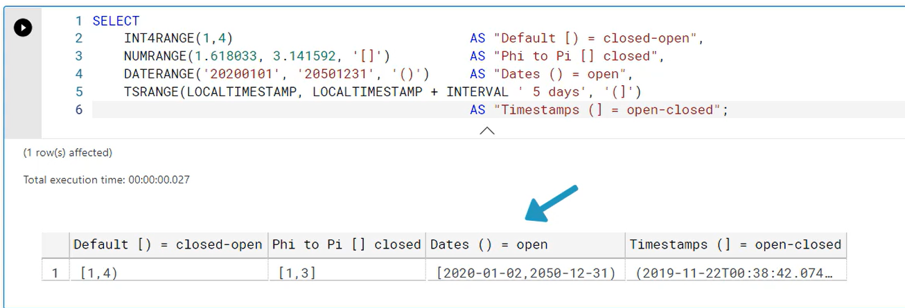

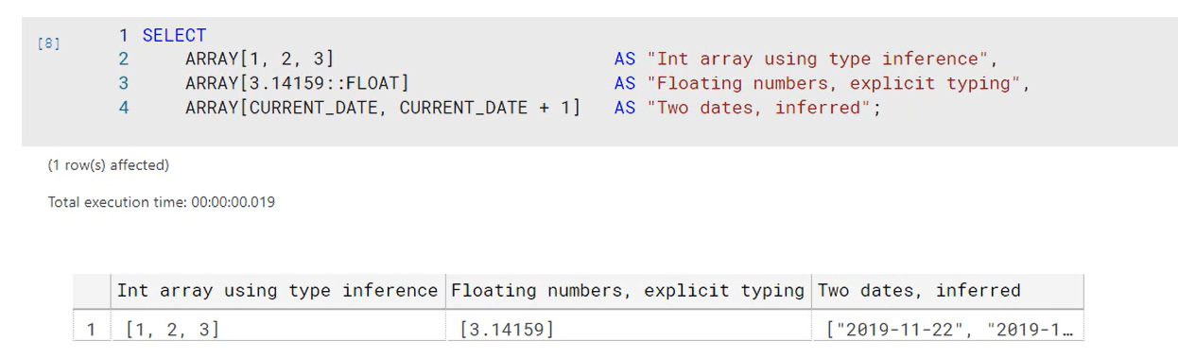

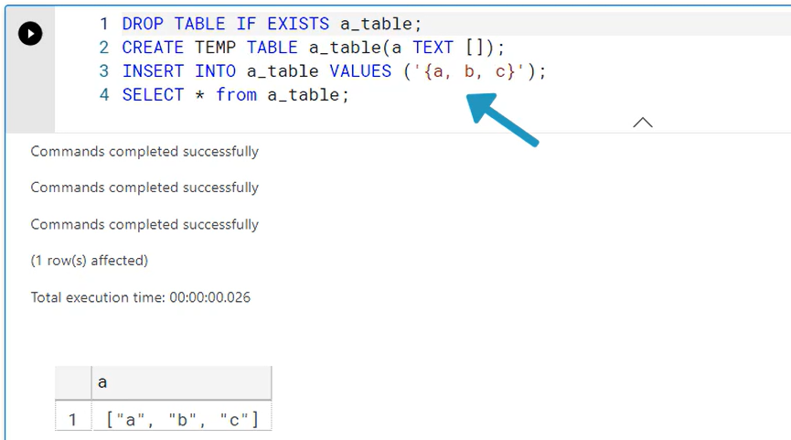

Using operators on range and arrays –

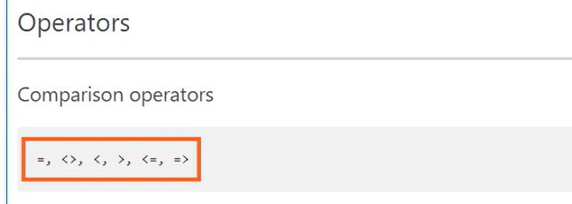

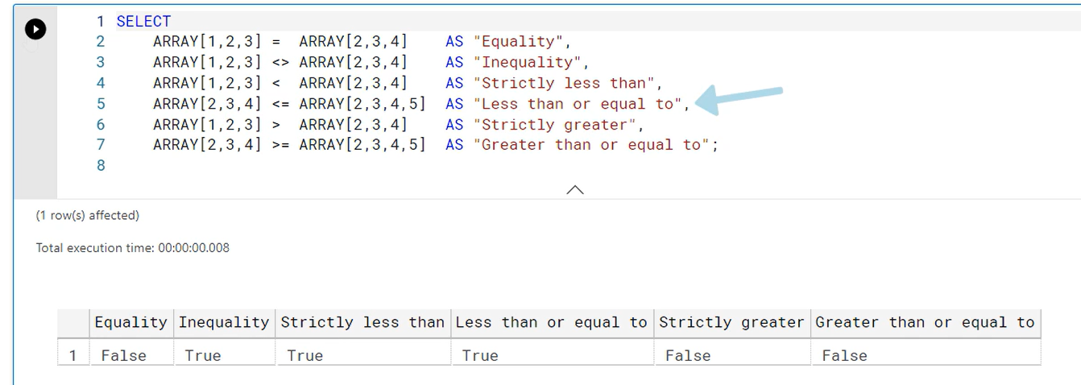

Specialized range and array functions –

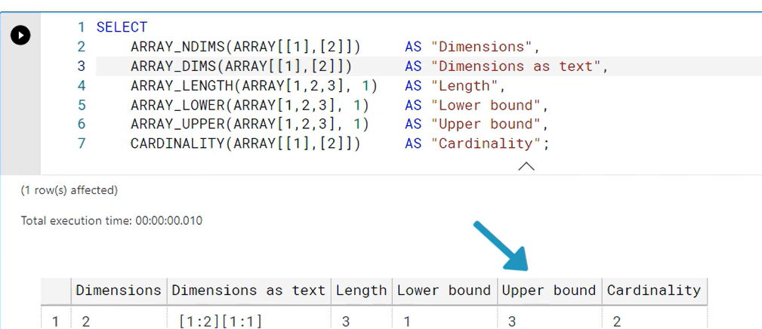

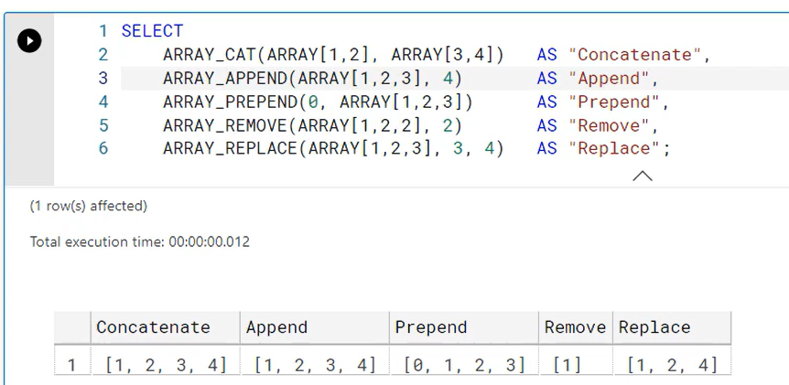

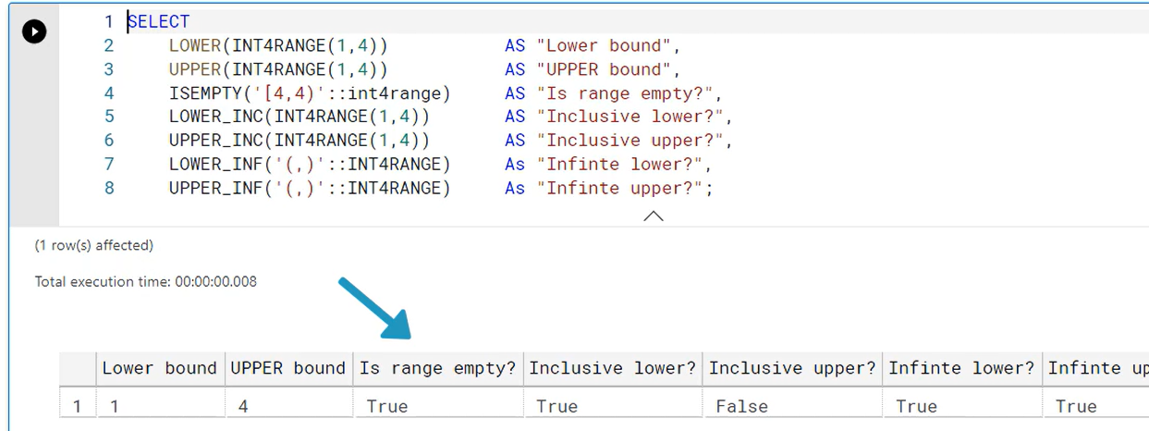

We can do array comparison using IN, ALL, ANY and SOME.

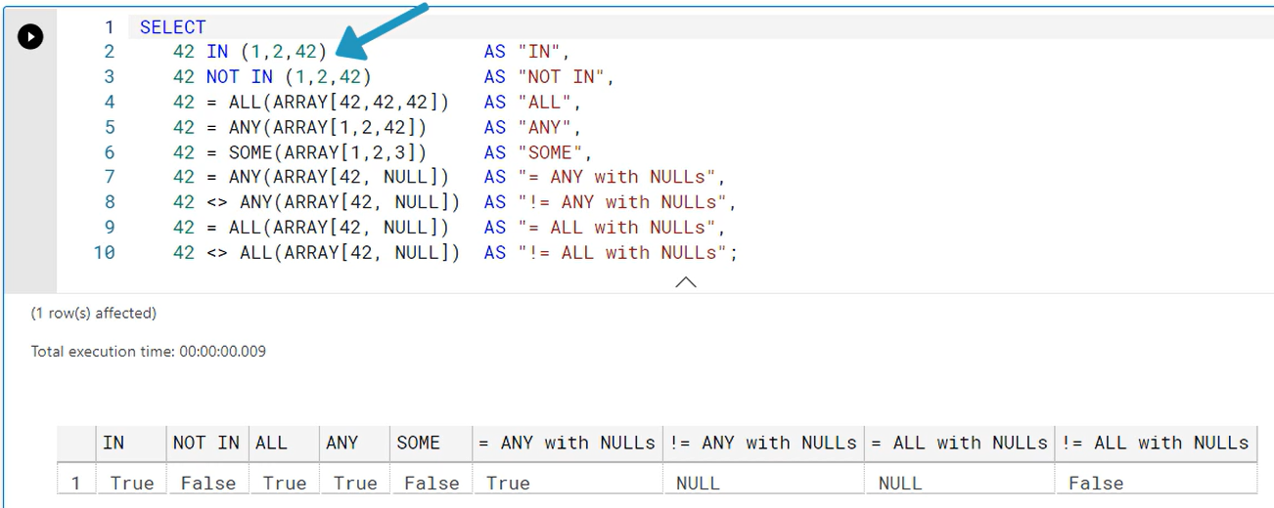

Converting formatting ranges and arrays-

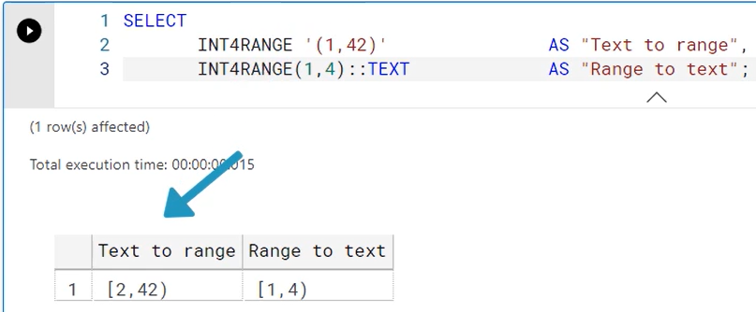

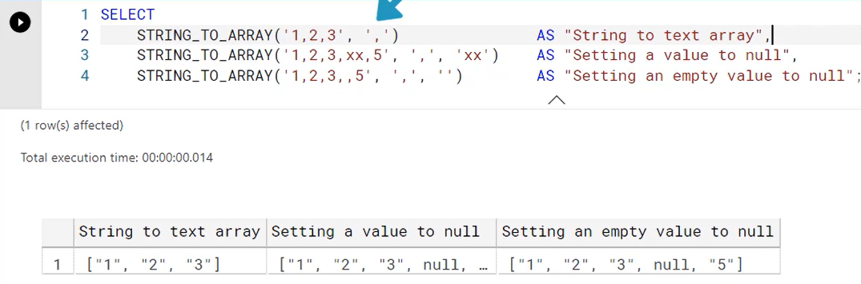

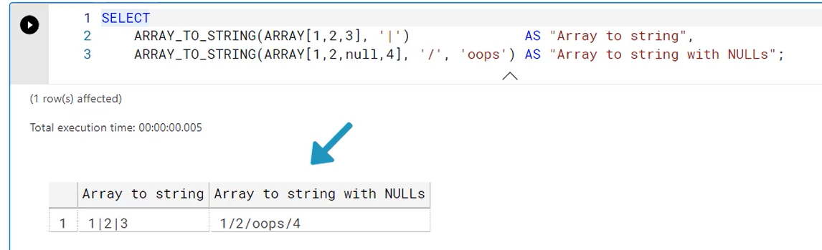

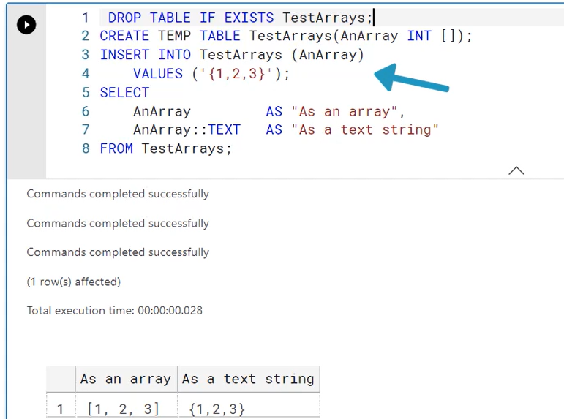

Digging into Metadata with System information and administration functions –

Informational schema view –

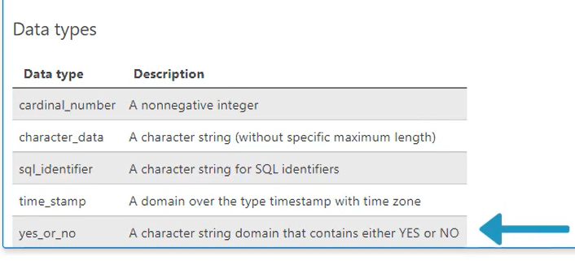

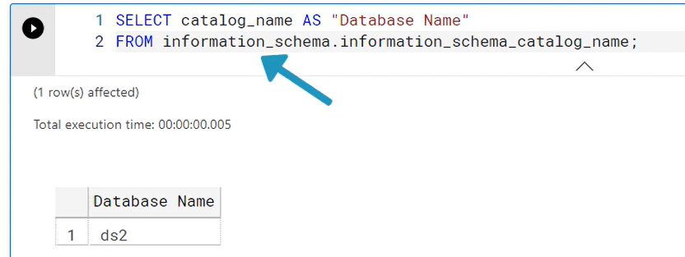

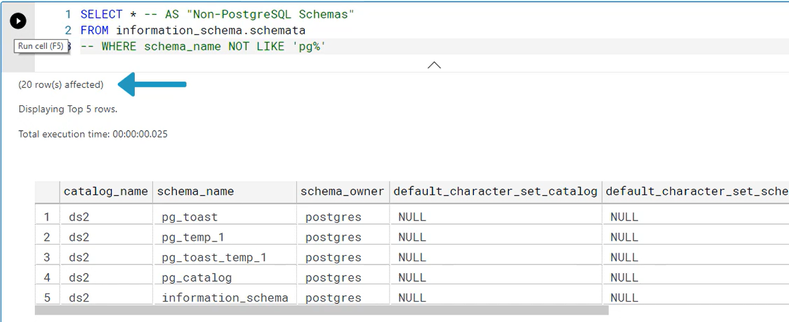

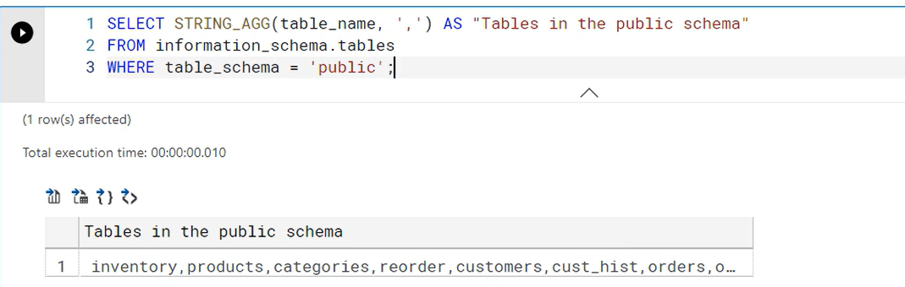

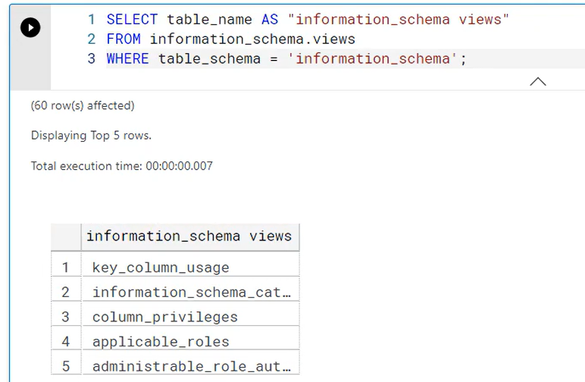

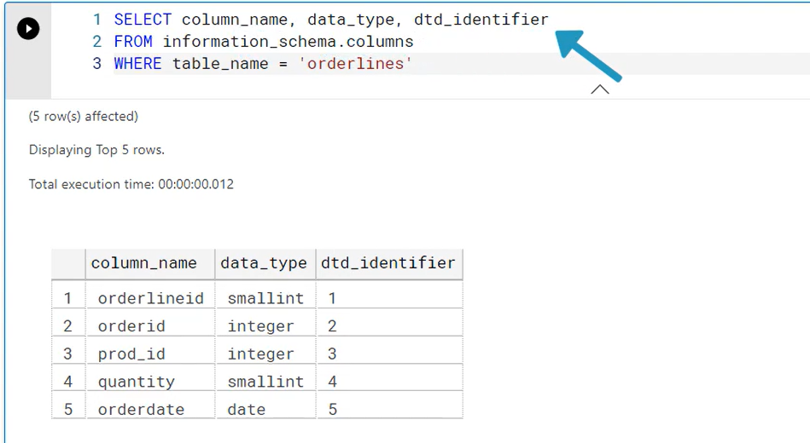

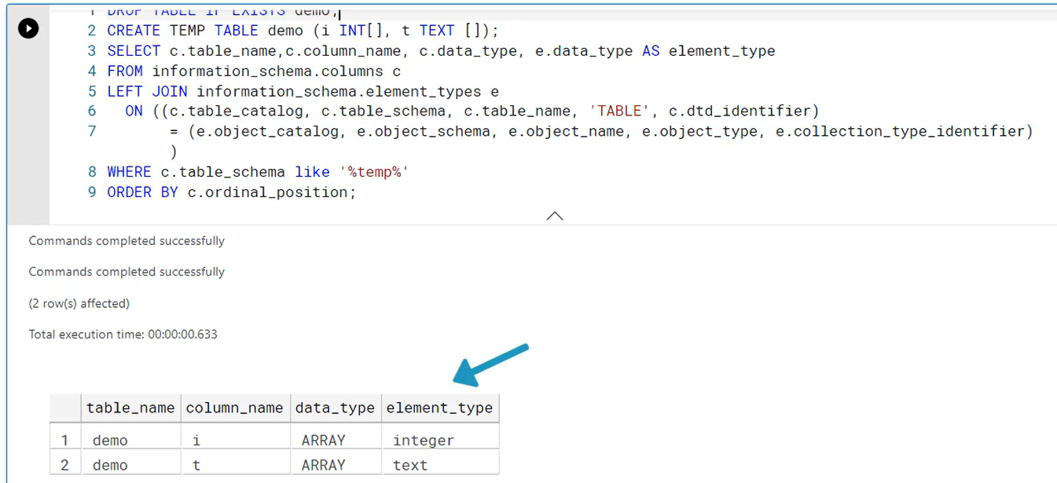

Using System information functions –

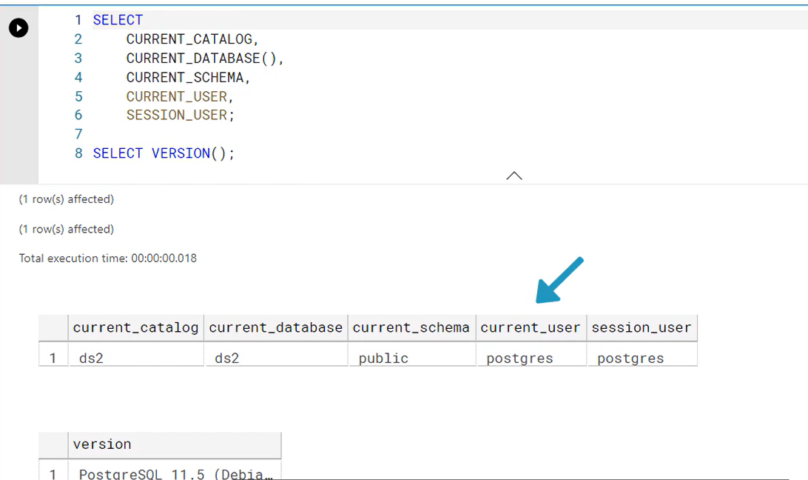

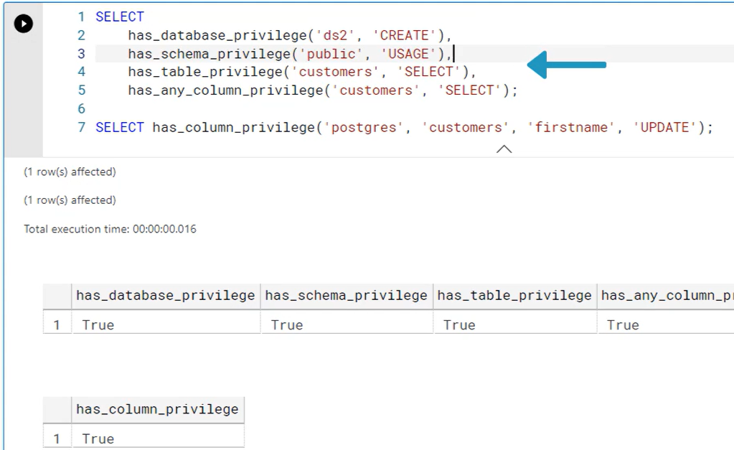

Administration functions –

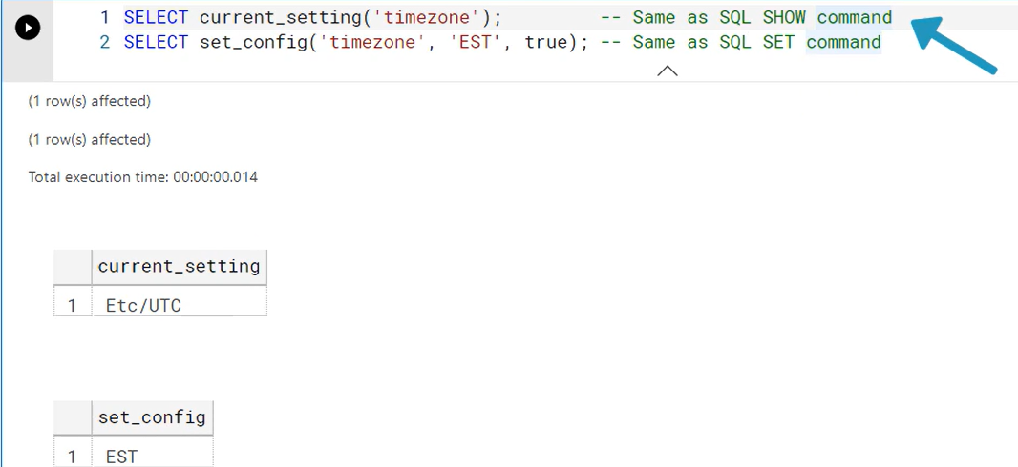

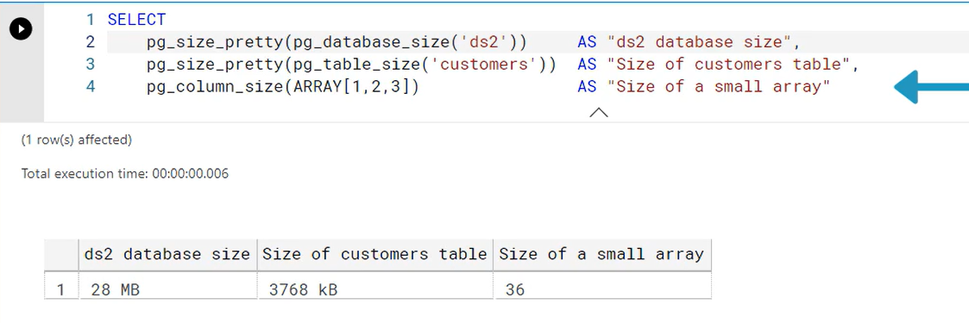

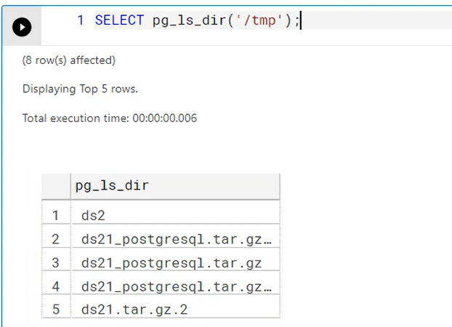

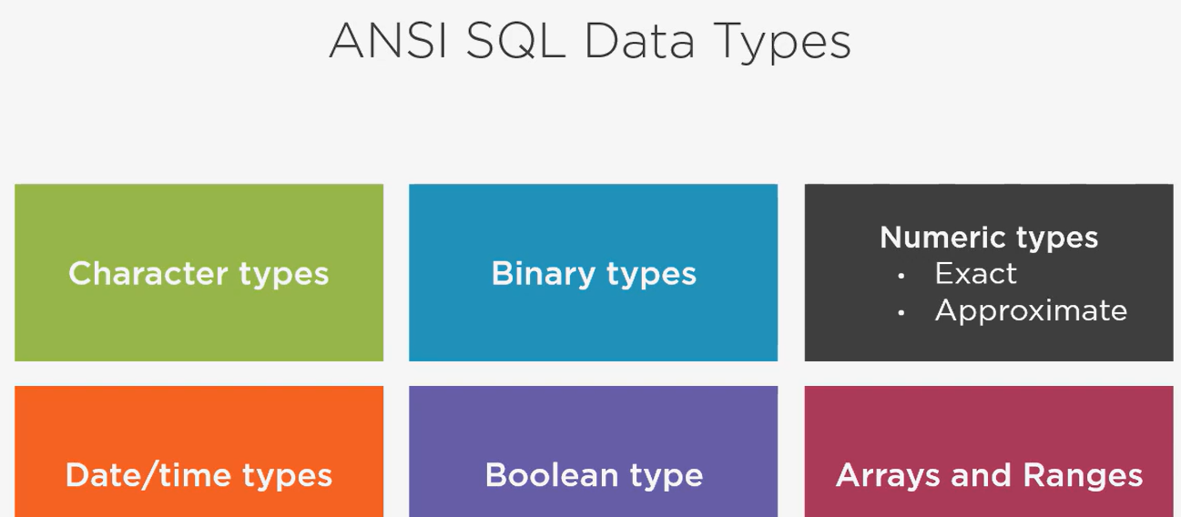

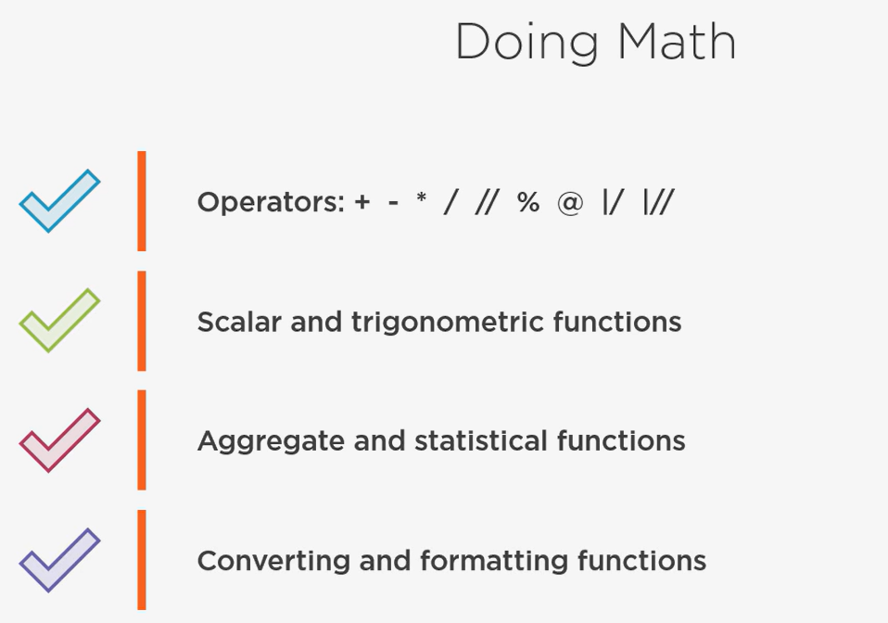

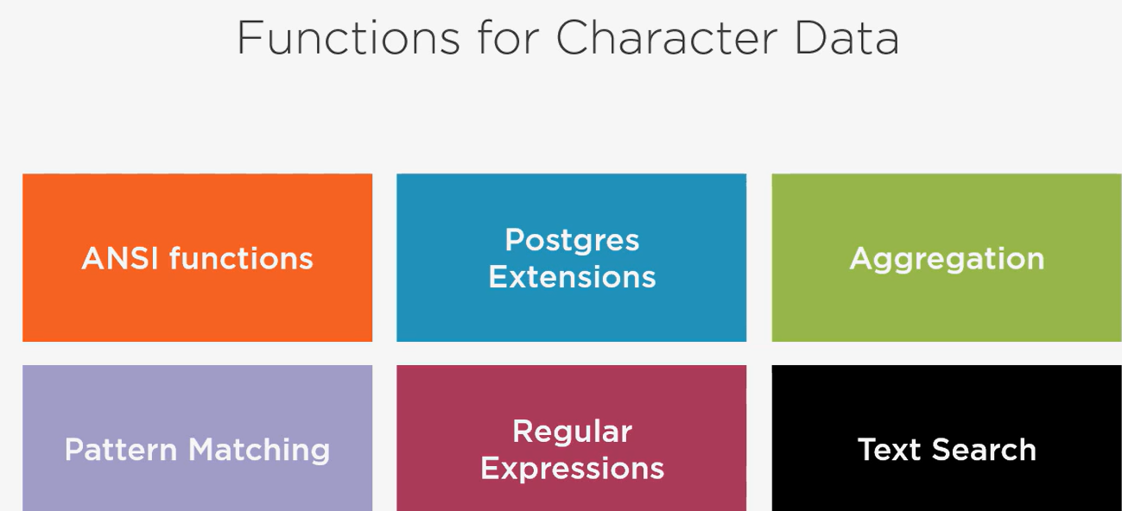

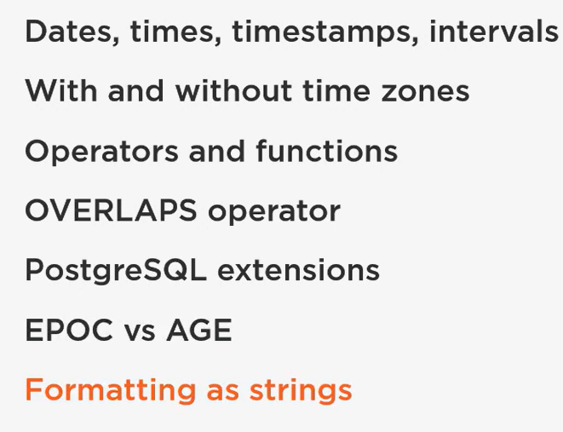

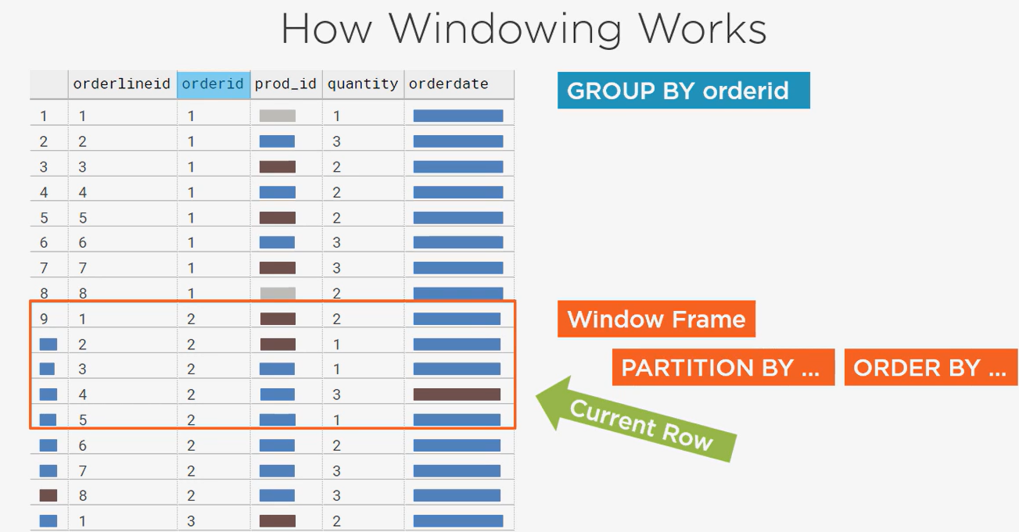

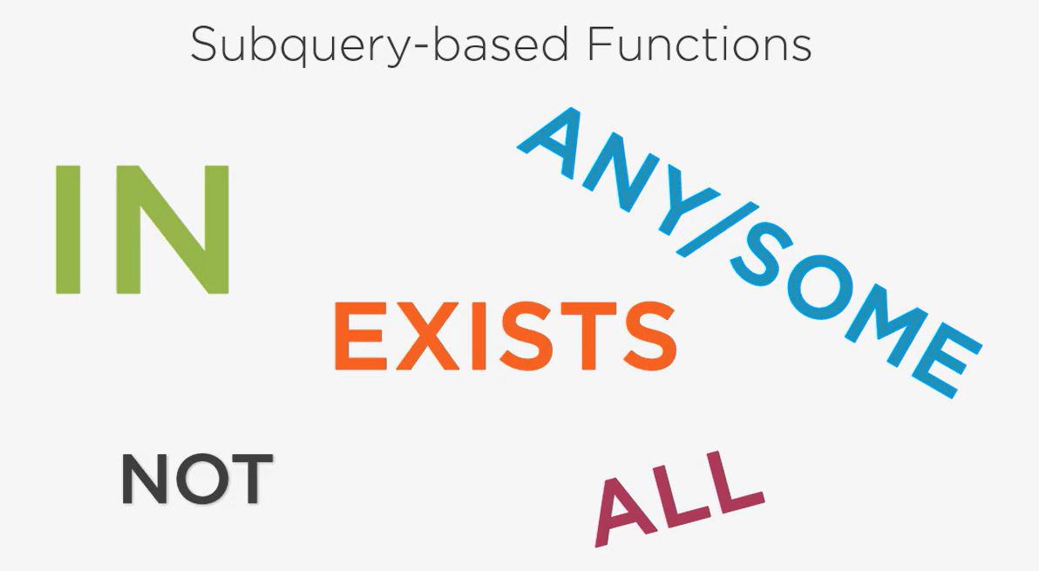

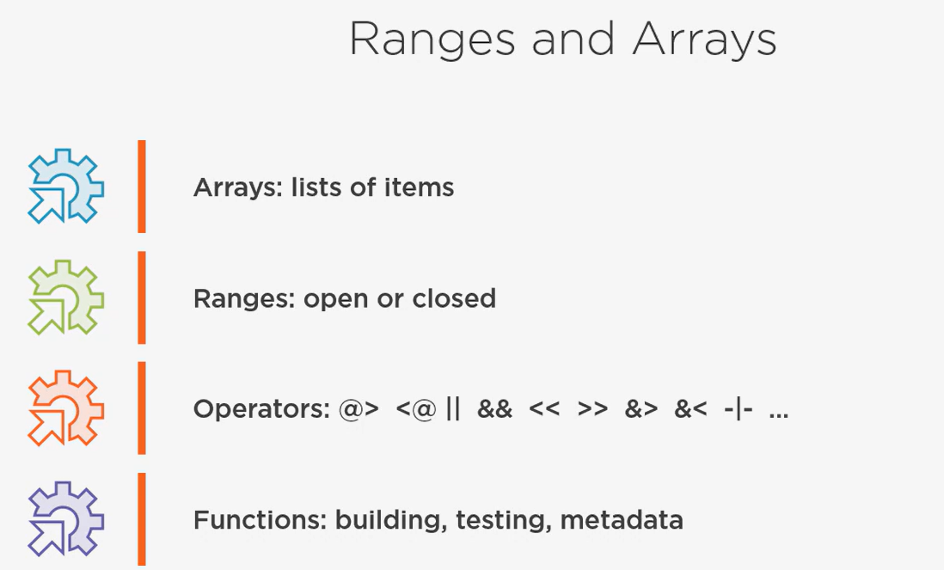

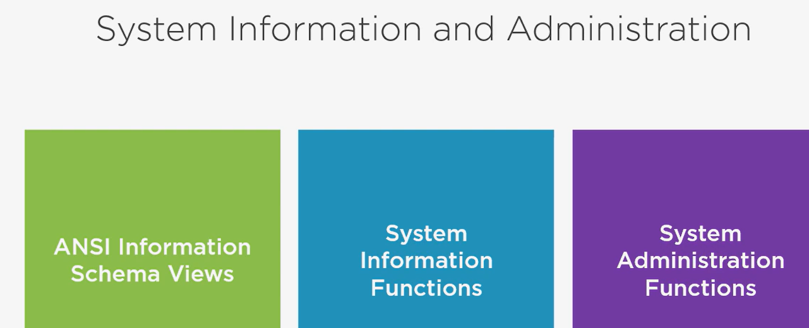

# Secure Coding Best Practices

Three main things – confidentiality, integrity and availability.

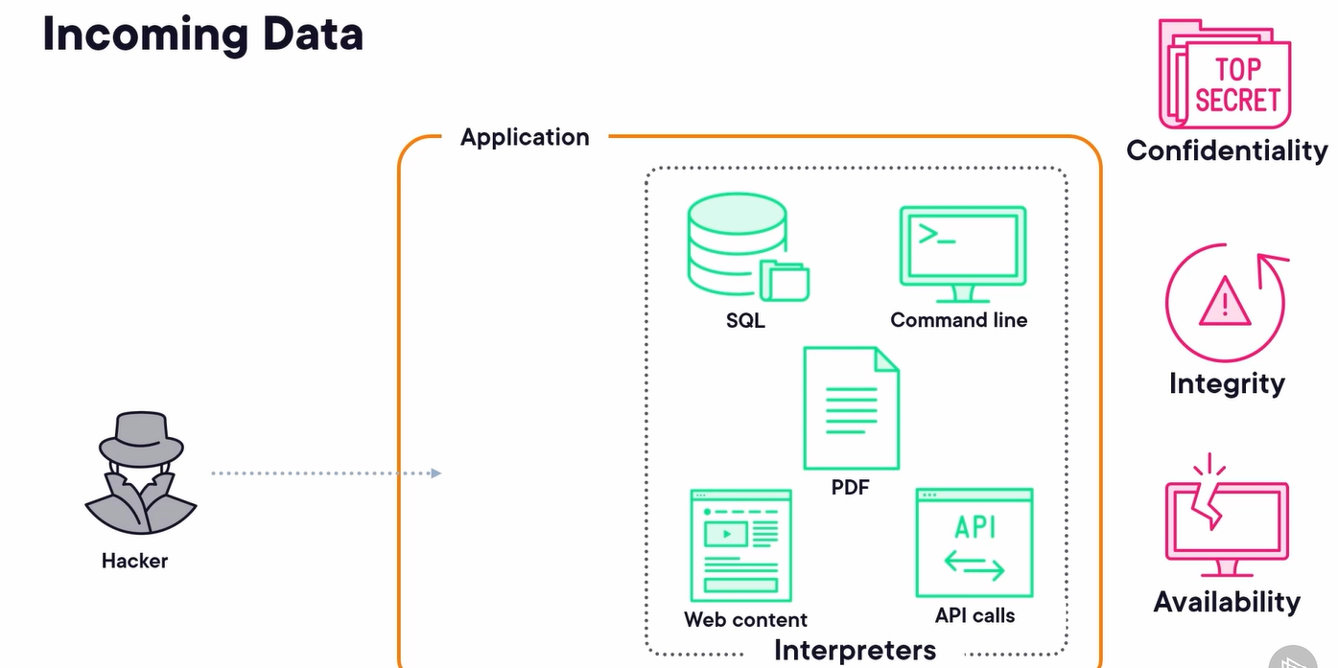

To maintain the integrity of the system, these interpreters should only accept the data from the users not commands –

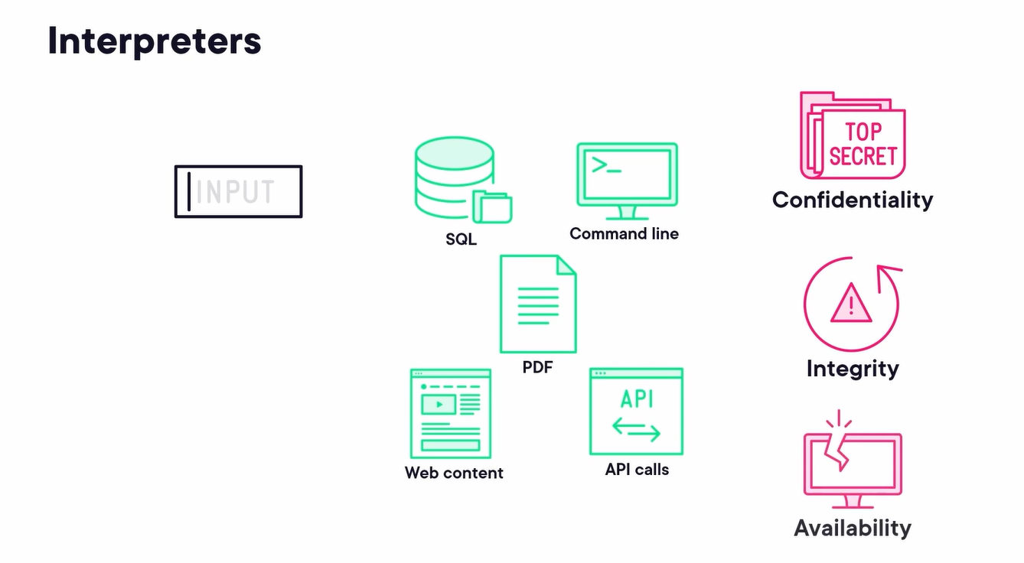

We avoid this we can use like sanitizing the user inputs, guidelines like least privilege, defense in depth, separation of duties, privacy by design, secure by design, secure by default, etc.

Key areas for security – secrets, authentication, authorization, file handling, injection, secure business logic, communication, data security, web client security, CI/CD, runtime security.